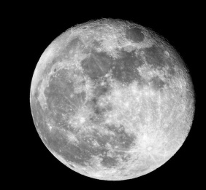
Year 2 – Week 1 – Moon Zoom
Phonics | English | Maths |  | Other Subject Areas
Day 1  ‘ow’ like in snow  https://www.youtube.com/watch?v=5CAQ1VtHrqI&feature=youtu.be  Read your reading book.  Please share or listen to three stories throughout the day. You can choose from the book list attached or you may have a book at home that you can read together. | Lesson 1  https://classroom.thenational.academy/lessons/to-listen-to-instructions-and-answer-questions-6mu64c?activity=video&step=1  Daily handwriting (ie):  https://teachhandwriting.co.uk/continuous-cursive-joins-choice-3.html  Practise ie on handwriting sheets. | Warm up activity:  https://www.bbc.co.uk/teach/supermovers/ks1-maths-number-bonds-with-martin-dougan/zf6cpg8  Lesson 1  Make Tally Charts activity  Watch the lesson and then complete the pages in your new maths workbook.  https://whiterosemaths.com/homelearning/year-2/spring-week-5-statistics/  Extra Challenge  Pick some numbers and see if you can represent them using tally marks.  e.g. 13 would look like this… |  | DT  Can you design your own rocket that could get you to the moon?  Draw a picture of what you would like your rocket to look like. You could add some labels if you like.  What could you use to make the different parts of the rocket? Will you paint it? How will you add the details? You have some different papers, card and foil in your pack that you could use. When you have finished think about what went well and what you might do differently if you made it again.  PE – Listen to the Let’s Move episode 1 – Journey to the Moon and join in with the movements and actions.  https://www.bbc.co.uk/programmes/b03g6vs2
Day 2  ‘u’ like in unicorn  https://www.youtube.com/watch?v=8LufmGmCryk&feature=youtu.be  Read your reading book.  Please share or listen to three stories throughout the day. You can choose from the book list attached or you may have a book at home that you can read together. | https://classroom.thenational.academy/lessons/to-tell-a-set-of-instructions-from-memory-c5hkar?activity=video&step=1  Lesson 2  Daily handwriting (se):  https://teachhandwriting.co.uk/continuous-cursive-joins-choice-3.html  Practise se in your book. | Warm up activity:  https://www.bbc.co.uk/teach/supermovers/ks1-maths-counting-with-john-farnworth/zbct8xs  Lesson 2  Make Tally Charts  Watch the lesson and then complete the pages in your maths workbook.  https://whiterosemaths.com/homelearning/year-2/spring-week-5-statistics/  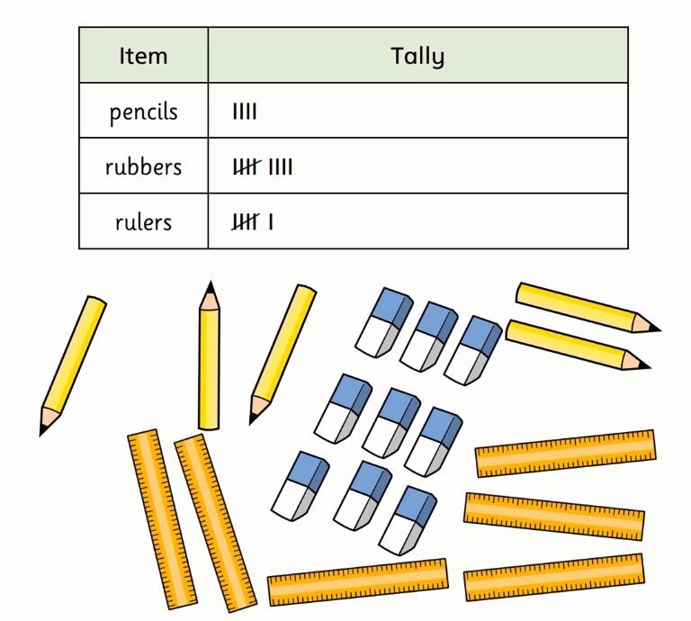  Extra Challenge  Go on a hunt around your home for something like chairs or cushions. Keep track of how many there are in your house by making a tally chart. |  | Music:  Listen to the solar system song on the following link:  https://www.youtube.com/watch?v=BZ-qLUIj_A0  Art  Look at the pictures of the different planets in your pack. Some planets are rocky and some are covered in swirling gases. Can you create your own solar system of colourful planets? Draw some different sized circles onto your white paper. Decide what colours and patterns your planets are going to have. Maybe some of them with have rings like Saturn. Use pencils, pens and paint or a mixture of these to create your own solar system. When they are dry, cut them out carefully and stick them on to your strip of black paper.  Extra Challenge  You could use your metallic crayon from your previous pack to draw stars, comets and asteroids onto the background and then you could think of a name for each of the planets in your solar system  PE: Cosmic kids yoga: Join in with the space adventure.  https://www.youtube.com/watch?v=v9W8iV4AJYQ
Day 3  Review  https://www.youtube.com/watch?v=mWuVo6desWM&feature=youtu.be  Read your reading book.  Please share or listen to three stories throughout the day. You can choose from the book list attached or you may have a book at home that you can read together. | https://classroom.thenational.academy/lessons/to-use-imperative-verbs-6tj32d  Lesson 3  Daily handwriting (her):  https://teachhandwriting.co.uk/continuous-cursive-joins-choice-3.html  Practise her in your book. | Warm up activity:  https://www.bbc.co.uk/teach/supermovers/ks1-maths-number-patterns-with-maggie-magpie/zvv7rj6  Lesson 3  Draw pictograms 1:1 activity  Watch the lesson and then complete the pages in your maths workbook.  https://whiterosemaths.com/homelearning/year-2/spring-week-5-statistics/  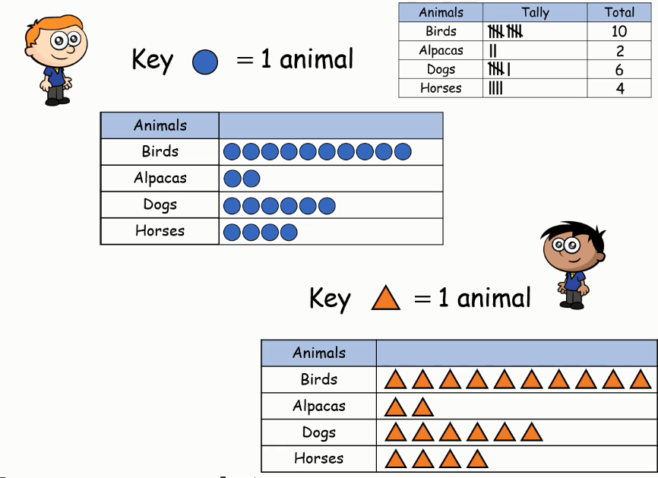  Extra Challenge  Can you create a life size pictogram by laying groups of objects out on a table or on the floor? You could make a life size pictogram to show toys, sweets or even clothes. |  | History  Watch this short video to find a little bit out about the moon.  https://www.bbc.co.uk/bitesize/clips/zy89wmn  Can you pretend to walk like you are on the moon?  The first person to walk on the moon was called Neil Armstrong. You can find out about him here.  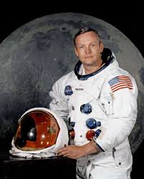  https://www.bbc.co.uk/bitesize/topics/zhpchbk/articles/z4w3mfr  Can you draw a picture of him landing the Eagle on the moon?  Extra challenge  Play this explorers game.  https://www.bbc.co.uk/bitesize/topics/zn3vvk7/articles/zsydr2p  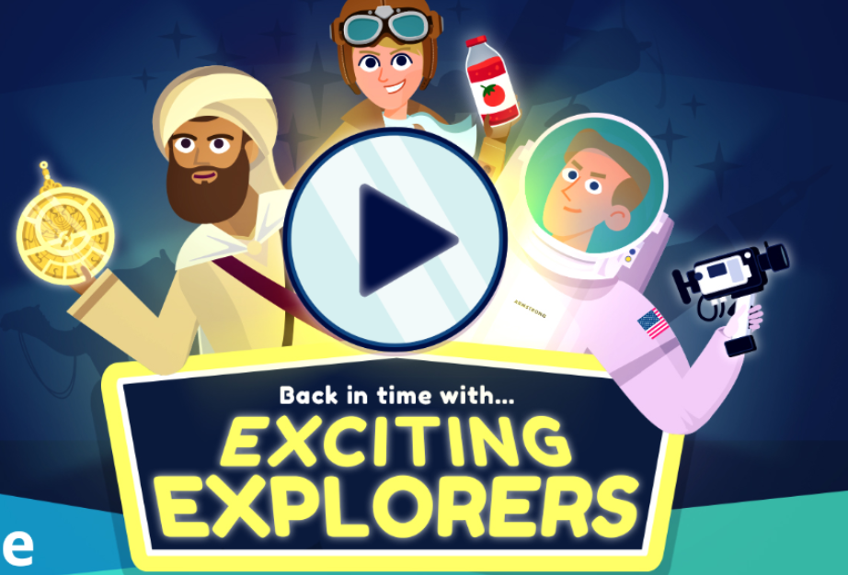
Day 4  ‘ph’ like in phone  https://www.youtube.com/watch?v=0Npby0U--FE&feature=youtu.be  Read your reading book.  Please share or listen to three stories throughout the day. You can choose from the book list attached or you may have a book at home that you can read together. | Warm up activity  https://www.bbc.co.uk/teach/supermovers/ks1-english-punctuation-with-karim-hacker/zrksqp3  https://classroom.thenational.academy/lessons/to-use-the-subordinating-conjunctions-when-and-if-cnh6ar  Lesson 4  Daily handwriting (men):  https://teachhandwriting.co.uk/continuous-cursive-joins-choice-3.html  Practise men in your book. | Warm up activity:  Watch Numberblocks - Tens Place  https://www.bbc.co.uk/iplayer/episode/m0005y9m/numberblocks-series-4-tens-place  Lesson 4  Draw pictograms 1:1  Watch the lesson and then complete the pages in your maths workbook.  https://whiterosemaths.com/homelearning/year-2/spring-week-5-statistics/  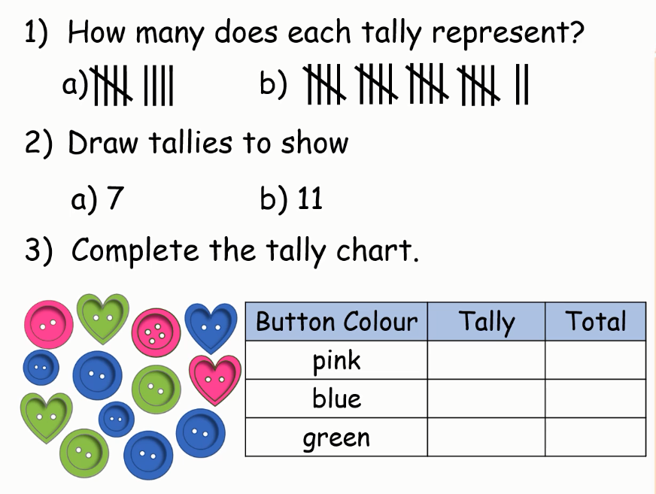  Extra Challenge  If you go out for a walk take a piece of paper and a pencil. Make a tally chart to show something that you see. It could be colours of cars, types of bird or even types of flower that you see. |  | Art  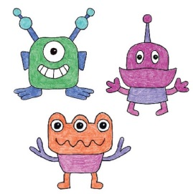  Nobody knows if there is life on any other planet in the galaxy.  Create your own alien drawings of what you think a being from another planet might look like. How many heads, arms, eyes or legs might they have? Create sketches of them using pencil or pen. You could colour them in too if you like. When you have finished pick your favourite to sculpt using your Model Magic. When it is dry you can paint it or colour it with pens.  PE  Listen and join in with the second episode ‘Meet the aliens’.  https://www.bbc.co.uk/programmes/b03g6vs3  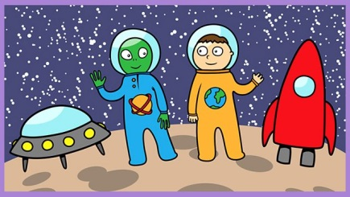
Day 5  ‘wh’ like in wheel  https://www.youtube.com/watch?v=cp0zG-QAlHk&feature=youtu.be  Read your reading book.  Please share or listen to three stories throughout the day. You can choose from the book list attached or you may have a book at home that you can read together. | Warm up activity:  Play the capital letters game on Small Town Superheroes.  https://www.bbc.co.uk/games/embed/small-town-superheroes?exitGameUrl=https%3A%2F%2Fbbc.co.uk%2Fbitesize%2Farticles%2Fzncgvk7  Lesson 5  https://classroom.thenational.academy/lessons/to-summarise-key-points-69k34d  Daily handwriting (oe):  https://teachhandwriting.co.uk/continuous-cursive-joins-choice-3.html  Practise oe in your book. | Warm up activity:  Lesson 5  Interpret pictograms 1:1  Watch the lesson and then complete the pages in your maths workbook.  https://whiterosemaths.com/homelearning/year-2/spring-week-5-statistics/ |  | Geography  Use Google maps to explore what the world might look like from space.  https://www.google.com/maps/@53.2202105,-22.2277193,4z  Can you zoom in and find where you live? Can you see which parts are the land and which parts are the sea? Can you find any other countries that you have heard of? Have ago at listening to this song and learning the names of the 7 continents.  https://www.youtube.com/watch?v=K6DSMZ8b3LE&ab_channel=Hopscotch  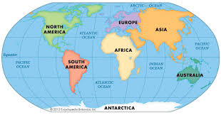  In your pack you have a continents jigsaw. Can you cut out the pieces really carefully and then put them back together to make the world and stick it into your book?  PE: Cosmic kids yoga: Join in with the space adventure.  https://www.youtube.com/watch?v=LZAaZDVqCiA

Year 2 - Week 2
Phonics | English | Maths |  | Other Subjects
Day 6  ‘ie’ like in field  https://www.youtube.com/watch?v=GeNyeTlz6l4&feature=youtu.be  Read your reading book.  Please share or listen to three stories throughout the day. You can choose from the book list attached or you may have a book at home that you can read together. | Warm up activity:  https://www.bbc.co.uk/teach/supermovers/ks1-english-adjectives-adverbs-with-johnny-inel/znfjbdm  Lesson 6  https://classroom.thenational.academy/lessons/to-box-up-for-purpose-69k3ed  Daily handwriting (re):  https://teachhandwriting.co.uk/continuous-cursive-joins-choice-3.html  Practise re in your book. | Warm up activity:  https://www.bbc.co.uk/teach/supermovers/ks1-maths-telling-the-time/zk4t8xs  Lesson 6  Draw Pictograms (2, 5 & 10) Activity  Watch the lesson and then complete the pages in your maths workbook.  https://whiterosemaths.com/homelearning/year-2/spring-week-6-statistics/  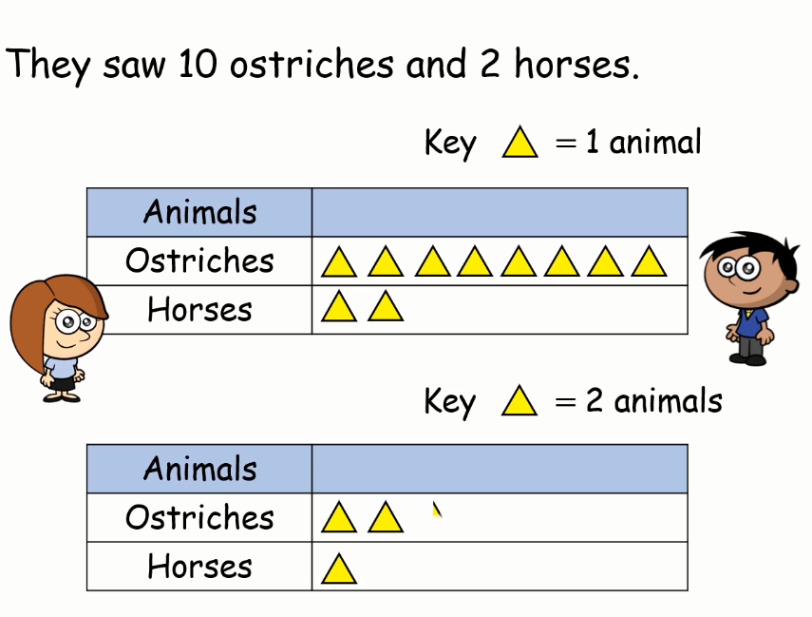  Extra Challenge  Practise counting in steps of 2, 5 and 10. How high can you go? |  | PSHE:  Going into space for the very first time must have been very scary for the astronauts but also very exciting. Have a look at your mood monster cards and see if you can act out each of the feelings. Turn all the cards face down. Take it in turns with someone in your house to turn over a card. If you can think of a time when someone might feel like that then you can keep the card. The winner is the person at the end with the most cards. Remember it is okay to feel any of these feelings. Can you create or draw your own mood monster?  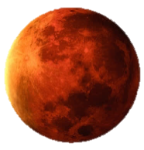  Music:  Listen to this piece of music called ‘Mars’ by a famous composer called Gustav Holst.  https://www.bbc.co.uk/programmes/p02fls7d  Can you draw a picture of what the music makes you think of as you listen to it? It could be a picture of something or you can just draw different lines and marks to go with the sounds you hear. If you have time rewind the video and look at the instruments in the orchestra. Do you know the names of any of the instruments? Can you hear what sounds they are making? See if you can find any of them in your orchestra picture.
Day 7  Review igh graphemes  https://www.youtube.com/watch?v=31SNwBMMLJw&feature=youtu.be  Read your reading book.  Please share or listen to three stories throughout the day. You can choose from the book list attached or you may have a book at home that you can read together. | Warm up activity:  https://www.bbc.co.uk/teach/supermovers/ks1-english-capital-letters-full-stops/zjmrhbk  Lesson 7  https://classroom.thenational.academy/lessons/to-identify-features-of-instructions-6hk6cc  Daily handwriting (ve):  https://teachhandwriting.co.uk/continuous-cursive-joins-choice-3.html  Practise ‘ve’ in your book. | Warm up activity:  https://www.bbc.co.uk/teach/supermovers/ks1-maths-money/zht4nrd  Lesson 7  Draw Pictograms (2, 5 & 10)  Watch the lesson and then complete the pages in your maths workbook.  https://whiterosemaths.com/homelearning/year-2/spring-week-6-statistics/  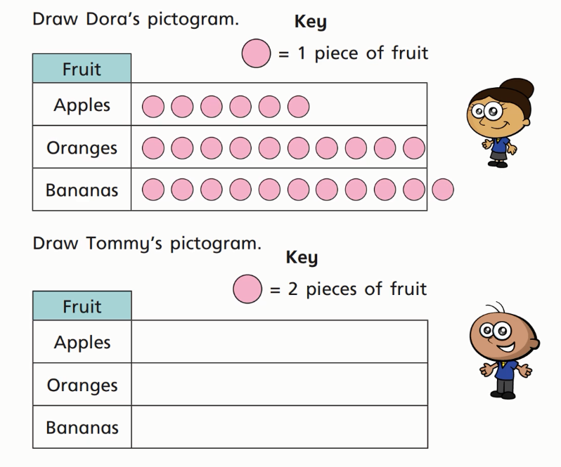 |  | Science  Find out about why we have day and night.  https://www.bbc.co.uk/bitesize/topics/zkvv4wx  Then have a go at the quiz with an adult.  Experiment  Use your small bottle of lemonade and raisins from your pack to have a go at the dancing raisins experiment in your pack. What happened when you put them in water? What happened when you put one in the lemonade?  Can you record a picture and a sentence to show what you noticed?  Extra Challenge – What do you think would happen if you put raisins into a different drink? What about milk, water, or cola? Do you think the same thing would happen? Why? Why not?
Day 8  Review ‘ai’ graphemes  https://www.youtube.com/watch?v=SmKy7qLZNBo&feature=youtu.be  Read your reading book.  Please share or listen to three stories throughout the day. You can choose from the book list attached or you may have a book at home that you can read together. | Warm Up Activity  https://www.bbc.co.uk/teach/supermovers/ks1-english-alphabet-with-naomi-wilkinson/zjjy2sg  Lesson 8  https://classroom.thenational.academy/lessons/to-write-a-clear-set-of-instructions-part-1-70rket  Daily handwriting (we):  https://teachhandwriting.co.uk/continuous-cursive-joins-choice-31.html  Practise ‘we’ in your book. | Warm Up  https://www.bbc.co.uk/teach/supermovers/ks1-maths-position-&-direction/zhh9scw  Lesson 8  Interpret pictograms  Watch the lesson and then complete the pages in your maths workbook.  https://whiterosemaths.com/homelearning/year-2/spring-week-6-statistics/  Extra Challenge  Can you think of some other questions you could ask about one of the pictograms? |  | PE – Warm up. Find a cushion or a pillow. Can you jump backwards and forwards over it 20 times without touching it or landing on it? Can you do it again with your feet together?  Make your own ball using a pair of socks. Make sure they are rolled together into a tight ball before you start. Can you throw it up and catch it 10 times in a row without dropping it? Can you throw it up and clap and catch it again? Can you throw it into a target like a plastic bowl or a washing basket? Can you make the target smaller? What extra challenges can you think of?  Extra Challenge  Can you create an astronaut work out? Think of some different exercises that they would have to do every day and make a list. Can you complete your own training challenge?  Find out what it is like living on the International Space Station on the following link:  https://www.esa.int/kids/en/Multimedia/Videos/Paxi_on_the_ISS/Living_in_space
Day 9  Review ‘oa’ graphemes  https://www.youtube.com/watch?v=wAZ3bX3B5aE&feature=youtu.be  Read your reading book.  Please share or listen to three stories throughout the day. You can choose from the book list attached or you may have a book at home that you can read together. | World Book Day  Today is World Book Day. Let’s celebrate how amazing books are!  Do you have a favourite book? Do you have a favourite author?  Celebrate World Book day by writing your own story or by retelling one of your favourite stories in your own way. You could make it in to a book if you like and add illustrations.  Share your story with someone in your house, you are an author! | Warm Up Activity  https://www.bbc.co.uk/iplayer/episode/p077rl69/numbersongs-counting-cars  Watch and join in with the counting.  Lesson 9  Use the little booklet in your pack to create your own maths book.  Can you include pages about shape? Number? Addition and subtraction? It could be a book to help a younger child learn to count maybe? Use your imagination. You could watch some episodes of Numberblocks to give you some ideas. Have fun with numbers. It could even be a story about one of the numbers.  https://www.bbc.co.uk/iplayer/episodes/b08bzfnh/numberblocks |  | World Book Day  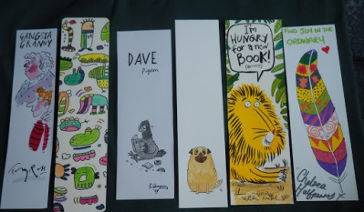  Make your own book mark. Use the strip of card in your pack to create a book mark. You could draw some of your favourite book characters on it. Colour it in using pens, pencils of paints. Remember to do both sides. When you have finished you can make a hole in one end with a pencil and thread some wool through and tie it up to make a little tassel. Now you can use your book mark in your favourite book or your school reading book.  DT  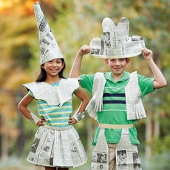  Can you dress up as an animal or character in a book? Maybe you will be Fantastic Mr Fox, Little Red Riding Hood, The Gruffalo? Use the paper and card in your pack to make your own outfit. You could cut out some ears and put them on a strip of paper that fits around your head. You could make a nose or a mask and tie it on with some wool maybe. There are lots of ideas here but you can use your imagination.  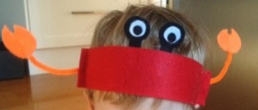  https://bookaid.org/support-us/world-book-day/world-book-day-dress-up/
Day 10  Review the week.  https://www.youtube.com/watch?v=ZlxFbjIra48&feature=youtu.be  Read your reading book.  Please share or listen to three stories throughout the day. You can choose from the book list attached or you may have a book at home that you can read together. | https://classroom.thenational.academy/lessons/to-write-a-clear-set-of-instructions-part-2-60v62e  Lesson 9  Daily handwriting (ere):  https://teachhandwriting.co.uk/continuous-cursive-joins-choice-3.html  Practise ere in your book. | Warm Up – Supermovers  https://www.bbc.co.uk/teach/supermovers/ks1-maths-length-height/zdrx92p  Draw Pictograms (2, 5 & 10) Activity  Watch the lesson and then complete the pages in your maths workbook.  https://whiterosemaths.com/homelearning/year-2/spring-week-6-statistics/ |  | DT  Create your own solar system using your paper plate.  Cut out the centre to create a hoop. Then paint or colour it in or paint it black. Create some stars and planets for your solar system, cut them out, and stick them on. You could hang it up somewhere to help you remember everything you have learned.  Music:  Listen to the solar system song again on the following link:  https://www.youtube.com/watch?v=BZ-qLUIj_A0
Extra Ideas
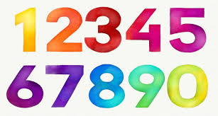Number formation practise sheets.
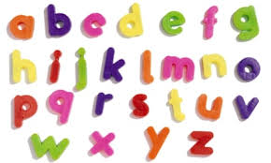Letter formation practise sheets.
It is recommended that your child listen to 3 stories every day so we have included a list and links to some lovely books in the pack. The author reads some of them.
Phonics play www.phonicsplay.co.uk

