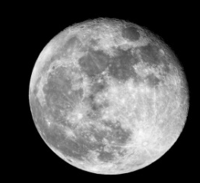
Year 1 – Week 1 – Moon Zoom
Phonics | English | Maths |  | Other Subject Areas
Day 1  ‘a-e’ like in make  https://www.youtube.com/watch?v=5CAQ1VtHrqI&feature=youtu.be  Read your reading book.  Please share or listen to three stories throughout the day. You can choose from the book list attached or you may have a book at home that you can read together. | Warm up  Play the full stops game on Small Town Superheroes.  https://www.bbc.co.uk/games/embed/small-town-superheroes?exitGameUrl=https%3A%2F%2Fbbc.co.uk%2Fbitesize%2Farticles%2Fzncgvk7  Watch Mrs Bannister read you the story on the link you have been sent.  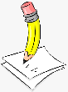  Cut up the pictures in your pack and sequence them in the correct order according to the story? Which part was your favourite? Choose one of the pictures that you like the best and think of a sentence to write about it. Say your sentence aloud to yourself or an adult. Does it make sense? Have a go at writing it down. Remember to use a capital at the beginning, spacing between words and a full stop at the end. Read it back to check it makes sense.  Practise your cursive handwriting. Watch the teaching of ‘wh’ on teach handwriting, by clicking on it, and then have a go at it for yourself in your book. Try to apply it into a few words.  https://teachhandwriting.co.uk/continuous-cursive-joins-choice-3.html | Warm up activity:  https://www.bbc.co.uk/teach/supermovers/ks1-maths-number-bonds-with-martin-dougan/zf6cpg8  Lesson 1: Counting to 50 by making tens.  Watch the lesson here:  https://whiterosemaths.com/homelearning/year-1/spring-week-5-number-place-value-within-50/  Now have a go at completing the pages in your workbook.  Extra Challenge  Can you have a go at writing all of the numbers up to 50 to make your own number line? |  | 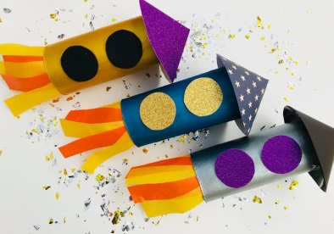  DT  Can you design your own rocket that could get you to the moon?  Draw a picture of what you would like your rocket to look like. You could add some labels if you like.  What could you use to make the different parts of the rocket? Will you paint it? How will you add the details? You have some different papers, card and foil in your pack that you could use. When you have finished think about what went well and what you might do differently if you made it again.  PE – Listen to the Let’s Move episode 1 – Journey to the Moon and join in with the movements and actions.  https://www.bbc.co.uk/programmes/b03g6vs2
Day 2  ‘i-e’ like in prize  https://www.youtube.com/watch?v=UQBFigKD7j4&feature=youtu.be  Read your reading book.  Please share or listen to three stories throughout the day. You can choose from the book list attached or you may have a book at home that you can read together. | Warm up activity:  Listen to the story again. In the story, the little bear asks the question, can I go to the moon?  If you were to meet little bear, what questions would you like to ask him about the adventure that he went on? Questions generally start with who, what, where, when and why. Your question has to make sense and it should help you to find out information. We use a ? at the end of a question. Eg. Where did you go? When did you go there? What did you take with you?  Make a list of questions in your book.  Practise your cursive handwriting. Watch the teaching of ‘ie’ on teach handwriting, by clicking on it, and then have a go at it for yourself in your book. Try to apply it into a few words.  https://teachhandwriting.co.uk/continuous-cursive-joins-choice-3.html | Warm up activity:  https://www.bbc.co.uk/teach/supermovers/ks1-maths-counting-with-john-farnworth/zbct8xs  Lesson 2: Numbers to 50  Have a go at counting up to 50 and back down again. Use your hundred square to help you.  Watch the lesson here:  https://whiterosemaths.com/homelearning/year-1/spring-week-5-number-place-value-within-50/  Now have a go at completing the pages in your workbook.  Now have a go at completing the pages in your workbook.  Extra challenge  Find something in your house that you have lots of, maybe pebbles, pasta pieces, pencils or you could even draw many spots on some paper. Have a go at counting them by organising them into groups and counting on any extra ones. |  | Music:  Listen to the solar system song on the following link:  https://www.youtube.com/watch?v=BZ-qLUIj_A0  Art  Look at the pictures of the different planets in your pack. Some planets are rocky and some are covered in swirling gases. Can you create your own solar system of colourful planets? Draw some different sized circles onto your white paper. Decide what colours and patterns your planets are going to have. Maybe some of them with have rings like Saturn. Use pencils, pens and paint or a mixture of these to create your own solar system. When they are dry, cut them out carefully and stick them on to your strip of black paper.  Extra Challenge  You could use your metallic crayon from your previous pack to draw stars, comets and asteroids onto the background and then you could think of a name for each of the planets in your solar system  PE: Cosmic kids yoga: Join in with the space adventure.  https://www.youtube.com/watch?v=v9W8iV4AJYQ
Day 3  ‘o-e’ like in woke  https://www.youtube.com/watch?v=UQBFigKD7j4&feature=youtu.be  Read your reading book.  Please share or listen to three stories throughout the day. You can choose from the book list attached or you may have a book at home that you can read together. | Warm up activity:  Can you sing the alphabet song and write down all the letters in the alphabet? https://www.youtube.com/watch?v=vD98OvvDNEs  Listen to the story again. Think carefully about what the little bear used to create his space outfit. Draw a picture of what you might wear if you had to dress up in a space outfit in the middle of a page in your book. Colour it in and think about words to describe each item you have drawn. Is it large, fluffy, smooth, purple etc.?  Add labels to your picture using an adjective to tell me more about each item e.g. green wellies, a shiny coat, warm gloves?  Extra challenge – Write sentences using some of the things you have labelled.  Practise your cursive handwriting. Watch the teaching of ‘oe’ on teach handwriting, by clicking on it and then have a go at it for yourself in your book. Try to apply it into a few words.  https://teachhandwriting.co.uk/continuous-cursive-joins-choice-3.html | Warm up activity:  https://www.bbc.co.uk/teach/supermovers/ks1-maths-number-patterns-with-maggie-magpie/zvv7rj6  Lesson 3: Counting forwards and backwards within 50  Have a go at counting up to 50. Each time you count a number do a little jump.  Watch the lesson here and then have a go at completing the pages in your workbook.  https://whiterosemaths.com/homelearning/year-1/spring-week-5-number-place-value-within-50/  Extra Challenge  Can you start on some different numbers and count on or back to 50 from them? |  | History  Watch this short video to find a little bit out about the moon.  https://www.bbc.co.uk/bitesize/clips/zy89wmn  Can you pretend to walk like you are on the moon?  The first person to walk on the moon was called Neil Armstrong. You can find out about him here.  https://www.bbc.co.uk/bitesize/topics/zhpchbk/articles/z4w3mfr  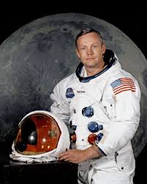  Can you draw a picture of him landing the Eagle on the moon?  Extra challenge  Play this explorers game.  https://www.bbc.co.uk/bitesize/topics/zn3vvk7/articles/zsydr2p  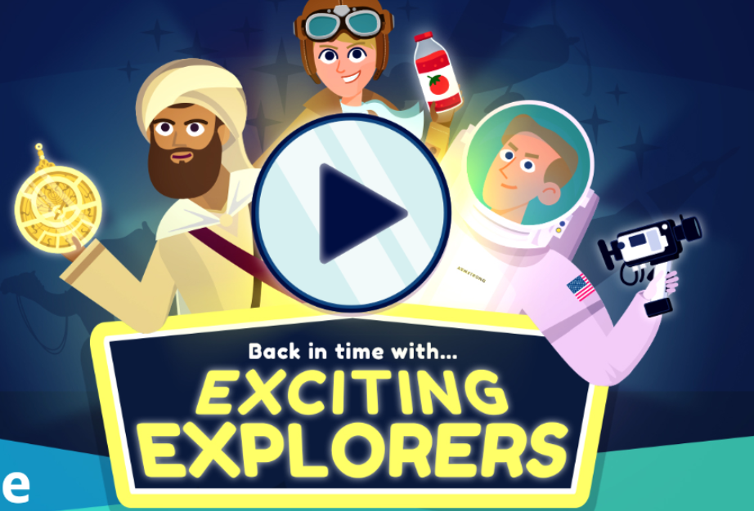
Day 4  ‘u-e ‘ like in cute  https://www.youtube.com/watch?v=xspQiDw0lDk&feature=youtu.be  Read your reading book.  Please share or listen to three stories throughout the day. You can choose from the book list attached or you may have a book at home that you can read together. | Warm up activity  https://www.bbc.co.uk/teach/supermovers/ks1-english-punctuation-with-karim-hacker/zrksqp3  On his journey the bear sees a plane full of people.  Draw a row of 5 people. As you draw them, think of names for each of them and have a go at writing them. Remember that names need a capital letter at the beginning. Sound them out carefully.  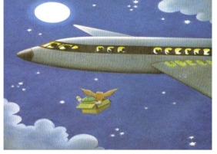  Write a sentence about some of your characters to say what they like. Try to use ‘and’ in your sentences so that you tell me two things about your character. E.g. Jim likes playing chess and eating jelly. They can be as silly and funny as you like but don’t forget to use spacing and a full stop at the end.  Practise your cursive handwriting. Watch the teaching of ‘but’ on teach handwriting, by clicking on it, and then have a go at it for yourself in your book.  https://teachhandwriting.co.uk/continuous-cursive-joins-choice-3.html | Warm up activity:  Watch Numberblocks - Tens Place  https://www.bbc.co.uk/iplayer/episode/m0005y9m/numberblocks-series-4-tens-place  Lesson 4: Tens and ones  Cut up your tens and ones cards before you start the lesson.  Watch the lesson here and then have a go at completing the pages in your workbook.  https://whiterosemaths.com/homelearning/year-1/spring-week-5-number-place-value-within-50/  Extra Challenge  What numbers can you make using your tens and ones cards? |  | Art  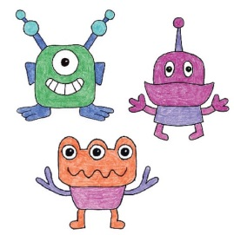  Nobody knows if there is life on any other planet in the galaxy.  Create your own alien drawings of what you think a being from another planet might look like. How many heads, arms, eyes or legs might they have? Create sketches of them using pencil or pen. You could colour them in too if you like. When you have finished pick your favourite to sculpt using your Model Magic. When it is dry you can paint it or colour it with pens.  PE  Listen and join in with the second episode ‘Meet the aliens’.  https://www.bbc.co.uk/programmes/b03g6vs3  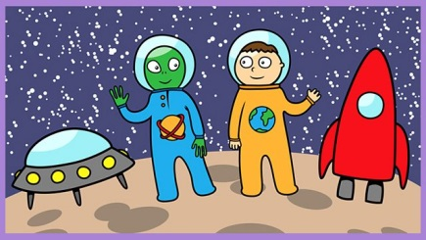
Day 5  Review of the week  https://www.youtube.com/watch?v=Y_RO2ajxOgQ&feature=youtu.be  Read your reading book.  Please share or listen to three stories throughout the day. You can choose from the book list attached or you may have a book at home that you can read together. | Warm up activity:  Play the capital letters game on Small Town Superheroes.  https://www.bbc.co.uk/games/embed/small-town-superheroes?exitGameUrl=https%3A%2F%2Fbbc.co.uk%2Fbitesize%2Farticles%2Fzncgvk7  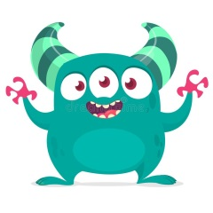  Design a fantastic picnic for an amazing journey into space. What delicious foods will you pack? Draw the foods into your book.  Label each one and use an adjective to describe them. You could take a juicy orange, red cherries or maybe crunchy carrots. Write a sentence to say which one of the foods you like the best.  Practise your cursive handwriting. Watch the teaching of ‘oo’ on teach handwriting, by clicking on it, and then have a go at it for yourself in your book. Try to apply it into a few words.  https://teachhandwriting.co.uk/continuous-cursive-joins-choice-3.html | Warm up activity:  Use your tens and ones cards to make a number. Can you say what your number is?  Lesson 5: Represent numbers to 50  Watch the lesson here and then have a go at completing the pages in your workbook.  https://whiterosemaths.com/homelearning/year-1/spring-week-5-number-place-value-within-50/ |  | Geography  Use Google maps to explore what the world might look like from space.  https://www.google.com/maps/@53.2202105,-22.2277193,4z  Can you zoom in and find where you live? Can you see which parts are the land and which parts are the sea? Can you find any other countries that you have heard of? Have ago at listening to this song and learning the names of the 7 continents.  https://www.youtube.com/watch?v=K6DSMZ8b3LE&ab_channel=Hopscotch  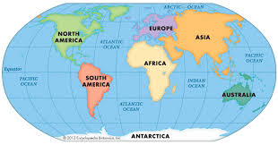  In your pack you have a continents jigsaw. Can you cut out the pieces really carefully and then put them back together to make the world and stick it into your book?  PE: Cosmic kids yoga: Join in with the space adventure.  https://www.youtube.com/watch?v=LZAaZDVqCiA

Year 1 - Week 2
Phonics | English | Maths |  | Other Subjects
Day 6  ‘e-e’ like in even  https://www.youtube.com/watch?v=5V-e55XOHCQ&feature=youtu.be  Read your reading book.  Please share or listen to three stories throughout the day. You can choose from the book list attached or you may have a book at home that you can read together. | Warm up activity:  https://www.bbc.co.uk/teach/supermovers/ks1-english-adjectives-adverbs-with-johnny-inel/znfjbdm  Watch the story again.  What do like about the story? Is there anything that you don’t like about it?  Can you use some card to make the characters from the story?  Use the puppets to have a go at changing the story so that something different happens. Will bear meet someone scary? Maybe something funny will happen.  Find someone to watch your story and maybe think of a name for it.  Practise your cursive handwriting. Watch the teaching of ‘ea’ on teach handwriting, by clicking on it, and then have a go at it for yourself in your book. Try to apply it into a few words.  https://teachhandwriting.co.uk/continuous-cursive-joins-choice-3.html | Warm up activity:  https://www.bbc.co.uk/teach/supermovers/ks1-maths-telling-the-time/zk4t8xs  Lesson 6: One more one less  Watch the lesson here and then have a go at completing the pages in your workbook.  https://whiterosemaths.com/homelearning/year-1/spring-week-6-number-place-value-within-50/  Extra challenge  Try finding one more and less of some things in your house. |  | PSHE:  Going into space for the very first time must have been very scary for the astronauts but also very exciting. Have a look at your mood monster cards and see if you can act out each of the feelings. Turn all the cards face down. Take it in turns with someone in your house to turn over a card. If you can think of a time when someone might feel like that then you can keep the card. The winner is the person at the end with the most cards. Remember it is okay to feel any of these feelings. Can you create or draw your own mood monster?  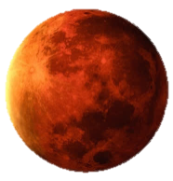  Music:  Listen to this piece of music called ‘Mars’ by a famous composer called Gustav Holst.  https://www.bbc.co.uk/programmes/p02fls7d  Can you draw a picture of what the music makes you think of as you listen to it? It could be a picture of something or you can just draw different lines and marks to go with the sounds you hear. If you have time rewind the video and look at the instruments in the orchestra. Do you know the names of any of the instruments? Can you hear what sounds they are making? See if you can find any of them in your orchestra picture.
Day 7  Review igh graphemes  https://www.youtube.com/watch?v=31SNwBMMLJw&feature=youtu.be  Read your reading book.  Please share or listen to three stories throughout the day. You can choose from the book list attached or you may have a book at home that you can read together. | Warm up activity:  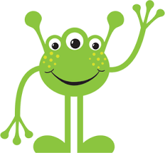  https://www.bbc.co.uk/teach/supermovers/ks1-english-capital-letters-full-stops/zjmrhbk  Imagine that the bear met an alien on the moon. What might it look like? Draw the alien he met and colour it in. Does it have long legs, green fur, a purple nose?  Have a good look at your alien. Give your alien a name, remember the capital letter! Then have a go at writing some sentences to describe it. Tell me two things about your alien. Use ‘and’ to join up your ideas. Eg. My alien is green and has 3 eyes. Say your sentences aloud before you write them down. Remember to use a full stop at the end of each sentence.  Practise your cursive handwriting. Watch the teaching of ‘igh’ on teach handwriting, by clicking on it, and then have a go at it for yourself in your book. Try to apply it into a few words.  https://teachhandwriting.co.uk/continuous-cursive-joins-choice-3.html | Warm up activity:  https://www.bbc.co.uk/teach/supermovers/ks1-maths-money/zht4nrd  Lesson 7: One more, one less  Watch the lesson here and then have a go at completing the pages in your workbook.  https://whiterosemaths.com/homelearning/year-1/spring-week-6-number-place-value-within-50/ |  | Science  Find out about why we have day and night.  https://www.bbc.co.uk/bitesize/topics/zkvv4wx  Then have a go at the quiz with an adult.  Experiment  Use your small bottle of lemonade and raisins from your pack to have a go at the dancing raisins experiment in your pack. What happened when you put them in water? What happened when you put one in the lemonade?  Can you record a picture and a sentence to show what you noticed?  Extra Challenge – What do you think would happen if you put raisins into a different drink? What about milk, water, or cola? Do you think the same thing would happen? Why? Why not?
Day 8  Review ‘ai’ graphemes  https://www.youtube.com/watch?v=SmKy7qLZNBo&feature=youtu.be  Read your reading book.  Please share or listen to three stories throughout the day. You can choose from the book list attached or you may have a book at home that you can read together. | Warm Up Activity  https://www.bbc.co.uk/teach/supermovers/ks1-english-alphabet-with-naomi-wilkinson/zjjy2sg  Plan your own story about a character that goes on an exciting adventure somewhere. What will they find to wear for their adventure? Draw a picture to show what they wear. What will they see on their journey? Draw 3 or 4 things that they will see. What will they do when they get where they are going? Will they have a picnic like the bear? Draw what they will do.  Then think about how they will get home again?  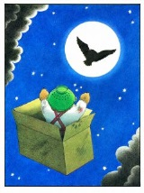  Is there someone who will say ‘Whatever next’ when they get back? Draw the end of your story. Now try acting it out yourself or use toys or draw puppets to help you remember your story.  Practise your cursive handwriting. Watch the teaching of ‘ai’ on teach handwriting, by clicking on it, and then have a go at it for yourself in your book. Try to apply it into a few words.  https://teachhandwriting.co.uk/continuous-cursive-joins-choice-3.html | Warm Up  https://www.bbc.co.uk/teach/supermovers/ks1-maths-position-&-direction/zhh9scw  Lesson 8: Compare objects to 50  Watch the lesson here and then have a go at completing the pages in your workbook.  https://whiterosemaths.com/homelearning/year-1/spring-week-6-number-place-value-within-50/ |  | PE – Warm up. Find a cushion or a pillow. Can you jump backwards and forwards over it 20 times without touching it or landing on it? Can you do it again with your feet together?  Make your own ball using a pair of socks. Make sure they are rolled together into a tight ball before you start. Can you throw it up and catch it 10 times in a row without dropping it? Can you throw it up and clap and catch it again? Can you throw it into a target like a plastic bowl or a washing basket? Can you make the target smaller? What extra challenges can you think of?  Extra Challenge  Can you create an astronaut work out? Think of some different exercises that they would have to do every day and make a list. Can you complete your own training challenge?  Find out what it is like living on the International Space Station on the following link:  https://www.esa.int/kids/en/Multimedia/Videos/Paxi_on_the_ISS/Living_in_space
Day 9  Review ‘oa’ graphemes  https://www.youtube.com/watch?v=wAZ3bX3B5aE&feature=youtu.be  Read your reading book.  Please share or listen to three stories throughout the day. You can choose from the book list attached or you may have a book at home that you can read together. | World Book Day  Today is World Book Day. Let’s celebrate how amazing books are!  Do you have a favourite book? Do you have a favourite author?  Today we are going to make our very own book using the ideas that we collected on our story map yesterday. Can you think of a title for your story to go on the front cover? You could call it ‘Whatever Next’ just like the one we have been reading if you want to. Draw or paint your illustrations into the little book in your pack. Then work on writing you sentences to tell your story. Try to remember to use a capital letter, spacing and a full stop in every sentence. Maybe you could use ‘and’ to make some of your sentences longer and maybe you could use some describing words too. Have fun being an author and an illustrator. You can finish your book tomorrow. | Warm Up Activity  https://www.bbc.co.uk/iplayer/episode/p077rl69/numbersongs-counting-cars  Watch and join in with the counting.  Lesson 9: Compare numbers within 50  Watch the lesson here and then have a go at completing the pages in your workbook.  https://whiterosemaths.com/homelearning/year-1/spring-week-6-number-place-value-within-50/  Extra Challenge  Can you use your little book in your pack to make your own little book about numbers? |  | World Book Day  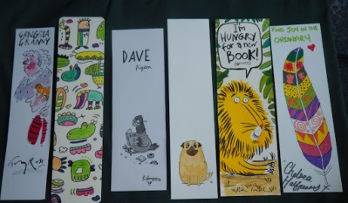  Make your own book mark. Use the strip of card in your pack to create a book mark. You could draw some of your favourite book characters on it. Colour it in using pens, pencils of paints. Remember to do both sides. When you have finished you can make a hole in one end with a pencil and thread some wool through and tie it up to make a little tassel. Now you can use your book mark in your favourite book or your school reading book.  DT  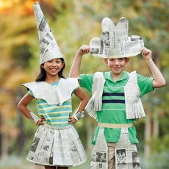  Can you dress up as an animal or character in a book? Maybe you will be Fantastic Mr Fox, Little Red Riding Hood, The Gruffalo? Use the paper and card in your pack to make your own outfit. You could cut out some ears and put them on a strip of paper that fits around your head. You could make a nose or a mask and tie it on with some wool maybe. There are lots of ideas here but you can use your imagination.  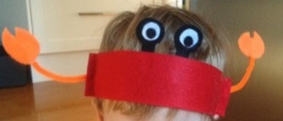  https://bookaid.org/support-us/world-book-day/world-book-day-dress-up/
Day 10  Review the week.  https://www.youtube.com/watch?v=ZlxFbjIra48&feature=youtu.be  Read your reading book.  Please share or listen to three stories throughout the day. You can choose from the book list attached or you may have a book at home that you can read together. | Finish off the book you made yesterday. Don’t forget to make a front cover and to write that the author is you. Check your work through to see if you have remembered all your capital letters and full stops and if it makes sense.  Read your story to someone else in your house. You could even read it to one of your toys or a pet.  Think about what you are really proud of in your writing.  Can you think of anything that you still want to get better at?  Practise your cursive handwriting. Watch the teaching of ‘be’ on teach handwriting, by clicking on it, and then have a go at it for yourself in your book.  https://teachhandwriting.co.uk/continuous-cursive-joins-choice-3.html | Warm Up – Supermovers  https://www.bbc.co.uk/teach/supermovers/ks1-maths-length-height/zdrx92p  Lesson 10: Order Numbers Within 50  Watch the lesson here and then have a go at completing the pages in your workbook.  https://whiterosemaths.com/homelearning/year-1/spring-week-6-number-place-value-within-50/ |  | DT  Create your own solar system using your paper plate.  Cut out the centre to create a hoop. Then paint or colour it in or paint it black. Create some stars and planets for your solar system, cut them out, and stick them on. You could hang it up somewhere to help you remember everything you have learned.  Music:  Listen to the solar system song again on the following link:  https://www.youtube.com/watch?v=BZ-qLUIj_A0

Extra Ideas
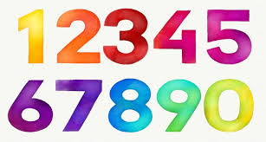Number formation practise sheets.

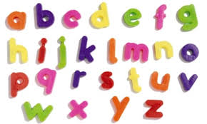Letter formation practise sheets.

It is recommended that your child listen to 3 stories every day so we have included a list and links to some lovely books in the pack. The author reads some of them.

Phonics play www.phonicsplay.co.uk

