EYFS - The Three Billy Goats Gruff
Daily – Try to read or watch at least 3 stories a day. Do some physical activities. You could do some Cosmic Kids Yoga (https://www.cosmickids.com/category/watch/ ), Go Noodle (https://www.gonoodle.com/ ) or Just Dance on You Tube. You could make up some different exercises to do at home.
Phonics | English | Maths |  | Physical Development, Understanding the World and Expressive Arts and Design
Day 1  https://www.youtube.com/watch?v=MoCnunAWbGk&feature=youtu.be  Lesson 11  ‘ai’ like in rain  A digraph is two letters that makes one sound.  Use your sound mat to spell the word ‘rain’.  Read your reading book. | https://classroom.thenational.academy/lessons/to-know-that-stories-have-problems-in-them-cnhkgr  Lesson 1  Watch this animation of The Three Billy Goats Gruff  https://www.youtub com/watch?v=xnxWzB-ba7c  Watch the letter formation for the letters r,v,w and then practise writing them in your book.  https://teachhandwriting.co.uk/continuous-cursive-beginners-choice-3.html | Watch the video  Session 1 – Representing and sorting 9 and 10.  https://whiterosemaths.com/homelearning/early-years/building-9-10-week-1/  Have a go at the activity.  How many different ways can you find of making 9 and 10?  Can you draw some of the different ways you found?  Work on writing the numbers 9 and 10 in your book. |  | Spend time enjoying the story together.  Think about the characters.  Listen to your teacher reading the story on the link you have been sent.  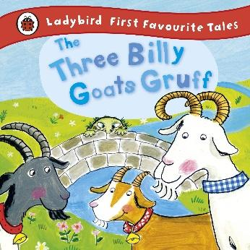  Make some finger puppets and a bridge to act and retell the story. Use this sheet in your learning pack.  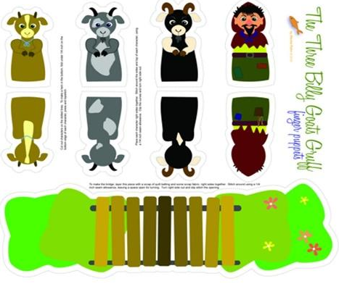  1. Cut out the puppets.  2. Glue just around the edges  leaving a hole for your finger  to go in.  3. Cut out the bridge and stick  the grass parts onto a piece  of paper, pushing them in to  make the bridge shape.  4. Explore using different voices for  each character.
Day 2  Lesson 12  ‘ee’ like in see  https://www.youtube.com/watch?v=cEffZUP4d_8&feature=youtu.be  Use your sound mat to write ‘see’ and ‘bee’.  Read your reading book. | https://classroom.thenational.academy/lessons/to-sing-and-map-the-story-6xgkar  Lesson 2  Listen to the song and see if you can join in with the new words to this familiar tune.  https://www.bbc.co.uk/teach/school-radio/eyfs-listen-and-play-billy-goats-gruff/zr3yt39  Use the story map template in your pack to draw pictures and tell the story of The Three Billy Goats Gruff.  Watch the letter formation for the letters n, m and then practise writing them in your book.  https://teachhandwriting.co.uk/continuous-cursive-beginners-choice-3.html | Watch the video  Session 2 – Representing and sorting 9 and 10.  https://whiterosemaths.com/homelearning/early-years/building-9-10-week-  Cut up your 9s and 10s cards and then work on sorting them into the two groups.  Can you make your own cards on the blank cards? What will you draw? You could represent 9 and 10 using real objects like pencils or grapes or socks before you draw your cards.  Extra activity – Can you count forwards and backwards to 10? |  | Physical Activity  Use your playdough to make a troll. Use the beads, buttons, sticks and straws in your pack to give him some features. Will you give him spiky hair or some horns?  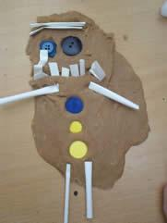  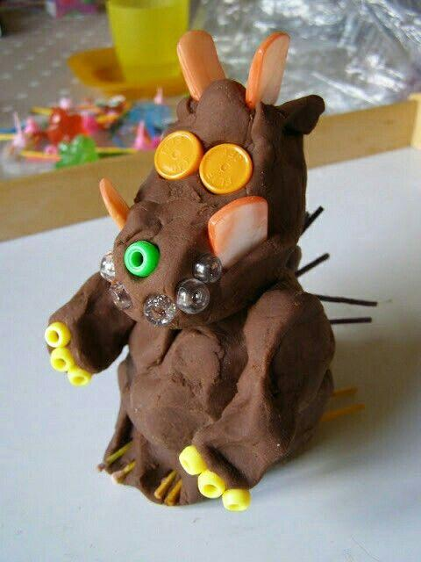  Draw a picture of the troll you have created. Now recycle your playdough and see if you can make the other characters from the story.
Day 3  Lesson 13  ‘igh’ like in light  https://www.youtube.com/watch?v=eoJXl-IkFF8&feature=youtu.be  In ‘igh’ the three letters are making one sound.  Write ‘light’ and ‘night’ in your book using your sound mat to help you.  Read your reading book. | https://classroom.thenational.academy/lessons/to-step-the-story-cmrk6c  Lesson 3  Act out the story using your finger puppets. Use the different voices you have been practising.  Watch the letter formation for the letters h, b and then practise writing them in your book.  https://teachhandwriting.co.uk/continuous-cursive-beginners-choice-3.html | Watch the video  Session 3 – Ordering numerals to 10  https://whiterosemaths.com/homelearning/early-years/building-9-10-week-  Can you put your number cards in order?  Get someone in your house to turn a card over. Can you tell which one it is? What if they swap two cards over? Can you spot the mistakes?  Play the ‘Teddy Numbers’ game and work on counting out the correct number to give to the teddy.  https://www.topmarks.co.uk/learning-to-count/teddy-numbers |  | Make a river  Use the different blue materials in your pack to make a river flow through the middle of your piece of art paper. Use your crayons, pens or paints to make one side have brown grass and the other side to have lovely green tasty grass.  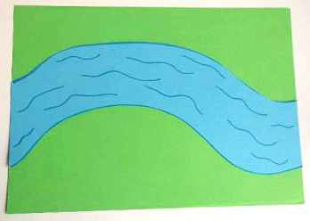  You could even use the green and brown pieces of paper in your pack to cut pieces of grass and stick them on also.  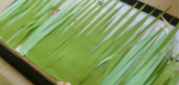
Day 4  Lesson 14  ‘oa’ like in goat  https://www.youtube.com/watch?v=d0X8phlr3Jc&feature=youtu.be  Try writing ‘goat’ and ‘coat’ in your book. Use your sound mat to help you sound out.  Read your reading book. | https://classroom.thenational.academy/lessons/to-mime-the-story-of-the-three-billy-goats-gruff-70w62e  Lesson 4  Create actions to retell the story. How would you trip, trap across a bridge? Would it be a fast or slow movement? Use your body to create the different actions and movements for each part of the story.  Watch the cosmic kids yoga video for the story. This might give you some ideas for the actions and movements.  https://cosmickids.com/video/the-three-billy-goats-gruff-app-preview/  Watch the letter formation for the letters p, u and then practise writing them in your book.  https://teachhandwriting.co.uk/continuous-cursive-beginners-choice-3.html | Watch the video  Session 4 – Composition of 9 and 10.  https://whiterosemaths.com/homelearning/early-years/building-9-10-week-  Can you add the pictures together in this game to find out how many there are altogether? Choose the correct number from the three choices.  https://www.topmarks.co.uk/addition/addition-to-10  Listen to the number 9 song. When you see the number, make the shape. Learn all about the number 9 with Numberblock Nine.  https://www.bbc.co.uk/cbeebies/watch/numberblocks-the-nine-song |  | Make a bridge  Use the art straws to construct a bridge that will go over the river you made yesterday. Think about how you will do this. Will you make the top of the bridge first or the sides? Will you use glue or masking tape to attach it together? How will you make it stand up? How can you make it strong so it doesn’t fall down? You could draw a picture first of what you would like it to look like.  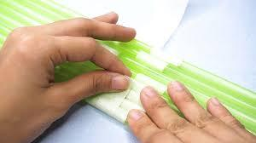  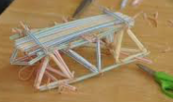  Listen to the song of London Bridge is Falling Down and lots of other rhymes.  https://www.youtube.com/watch?v=0r57cS_C2O8
Day 5  Lesson 15 – review the week  https://www.youtube.com/watch?v=MvaPYJ0ahVc&feature=youtu.be  Read your reading book.  Use your sound mat to spell some words from this week. | https://classroom.thenational.academy/lessons/to-tell-the-story-independently-70t3cc  Lesson 5  Use the character speech bubble activity sheet to write a word or sentence that each character might say.  Now use this, your story map and finger puppets to help you retell the story but try and think of a different ending.  Practise writing all of the letters from this week r,v,w,n,m,h,b,p,u  https://teachhandwriting.co.uk/continuous-cursive-beginners-choice-3.html | Watch the video  Session 5 – Numbers to 10 Bingo.  https://whiterosemaths.com/homelearning/early-years/building-9-10-week-  Have fun playing the Bingo game with someone in your family.  Solve the robot number sentence problems to find the correct answer.  https://www.topmarks.co.uk/maths-games/robot-more-or-less  Listen to the number 10 song. When you see the number, make the shape. Learn all about the number 10 with Numberblock Ten.  https://www.bbc.co.uk/cbeebies/watch/numberblocks-the-ten-song |  | Split pin goats  Cut out the parts of each goat in your pack and then ask your grown up to help you make the holes where the crosses are. Push a split pin through the holes, push open the ends of the pin to secure it and make the legs move.  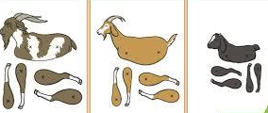  Watch this video of the story and recreate the yoga poses for the goats in the story.  https://www.bbc.co.uk/iplayer/episode/p064kjkd/happy-tent-tales-3three-billy-goats-gruff  Paper plate goat  Watch this video showing you how to make a paper plate goat.  https://www.youtube.com/watch?v=EZ_sp5RzdLs  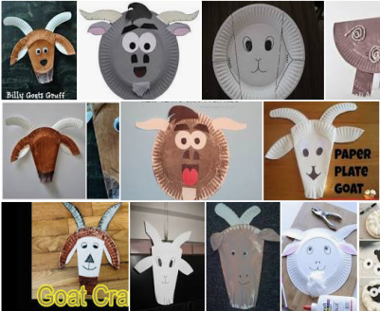  Here are some different ideas for you to choose from.  You have an extra paper plate so you can design and make one of your own creations.

EYFS The 3 Billy Goats Gruff
Phonics | English | Maths |  | Physical, Knowledge and Understanding of the World and Expressive Arts
Day 6  Lesson 16 – ‘oo’ like in moon  https://www.youtube.com/watch?v=Nw_6ZaV3KpE&feature=youtu.be  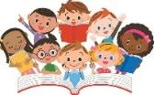  Read your reading book. | https://classroom.thenational.academy/lessons/to-recycle-the-story-of-the-three-billy-goats-gruff-6xjk6t  Lesson 6  Think of some different characters you could use in your own version of the story. Draw pictures of them in your home learning book and label them.  Watch the letter formation for the digraph ai and then practise writing the digraph in your book.  https://teachhandwriting.co.uk/continuous-cursive-joins-choice-3.html | Watch the video  Session 1 – Counting back from 10 – 10 in a bed  Can you use your number cards to help you count back from 10 to 1? Then lay them out in order from 10 to 1.  Watch and enjoy joining in with the ten in a bed rhyme.  https://www.bbc.co.uk/teach/school-radio/nursery-rhymes-ten-in-the-bed/z7bnmfr |  | Make a troll  Design a troll in your home learning book. Think about the features it will have.  - Tear or cut your coloured paper to make a troll face and body.  - Add his features such as teeth, warts and hair. You can use straws, wool and tissue paper from your pack.  - Design and draw some clothes for it. Cut them out and stick them on to the body.  Now you can use your split pin goats, straw bridge and the troll you have just made to retell the story of the Three Billy Goats Gruff to someone in your house.
Day 7  Lesson 17 – ‘oo’ like in book  https://www.youtube.com/watch?v=MDysETvGN_I&feature=youtu.be  Use your sound mat to spell the word ‘look’.  Read your reading book. | https://classroom.thenational.academy/lessons/to-create-a-telling-of-a-recycled-story-75j30d  Lesson 7  Look at the new characters you thought of yesterday. Can you think of words to describe them? Write these words underneath your character. You could try and write a sentence using the tricky word ‘The’.  Use the letter formation sheet in your pack to practise writing the digraph ee. | Watch the video  Session 2 – Comparing numbers within 10.  https://whiterosemaths.com/homelearning/early-years/building-9-10-week-2/  Play the game with someone in your family.  Have fun playing the ladybird ordering game here.  https://www.topmarks.co.uk/learning-to-count/ladybird-spots |  | Cress head troll  - Find the pot in your pack and decorate with a troll face.  - Fill the pot with your cotton wool.  - Dampen the cotton wool with a few drops of water.  - Sprinkle your cress seeds on the top.  - Place your pot in a light place near a window and watch your cress seeds grow over the next two or three days.  - You might like to taste your cress when it has grown tall.  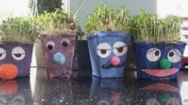
Day 8  Lesson 18 – ‘ar’ like in car.  https://www.youtube.com/watch?v=IUHj1V-KYeg&feature=youtu.be  Use your sound mat to spell the word ‘park’.  Read your reading book. | https://classroom.thenational.academy/lessons/to-sing-and-tep-out-the-new-story-chh3gc  Lesson 8  Use the template cards in your pack to write words and draw pictures of your new version of the story.  Watch the letter formation for the digraph igh and then practise writing the digraph in your book.  https://teachhandwriting.co.uk/continuous-cursive-joins-choice-3.html | Watch the video  Session 3 – Comparing numbers within 10  https://whiterosemaths.com/homelearning/early-years/building-9-10-week-2/  Cut up the domino cards and then have a go at playing the game.  Can you draw all the dominoes that have fewer than 5 spots? |  | Fine motor activity  You will find brown and green straws in your pack. Firstly, you will need to cut them into different size pieces. Can you order them from the shortest to the longest?  Now mix them all together so you have one pile of brown and green pieces. Use the peg in your pack to try and pick them up one at a time and put the green ones on one side of your straw bridge and the brown ones on the other side.  Listen to the days of the week song while you are completing this activity.  https://www.bbc.co.uk/cbeebies/curations/days-of-the-week-songs  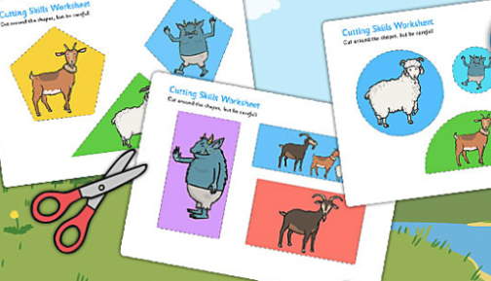  Practise your scissor skills by cutting out these different shapes of the characters from the story.
Day 9  World Book Day  Lesson 19 – ‘or’ like in horn.  https://www.youtube.com/watch?v=HbRKL68I1WQ&feature=youtu.be  Read your reading book. | World Book Day  Listen to your teacher reading the story of Aliens Love Underpants on the school blog  http://www.ilfraco beinf.devon.sch.uk/blog/  Watch this clip and see if you can draw a picture or write a list of the different characters who wore underpants. Who was your favourite?  Make your own mini book  See the instructions in your pack. There are two different ways of making a mini book and then you can make as many books as you like. | World Book Day  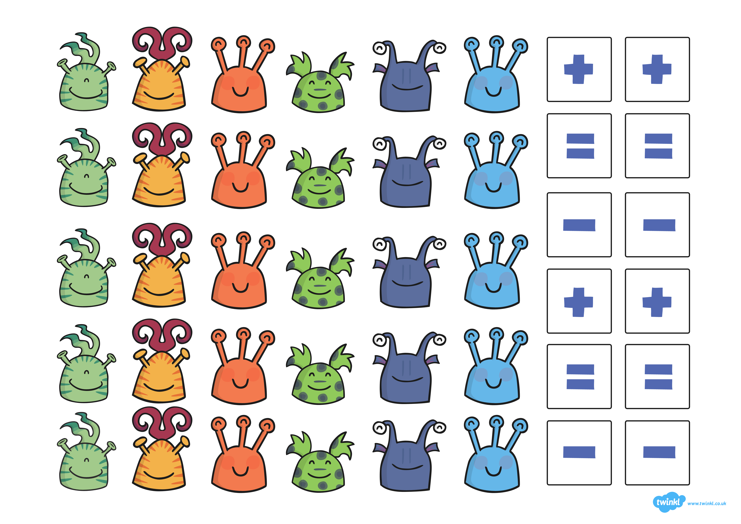  Use the activity sheet in your pack to cut out the aliens and create some addition and take away sums.  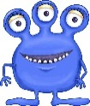 +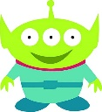 =3  Make an alien headband using the template in your pack. Can you write the numbers 0-10 or 0-20 on it from one end to the other?  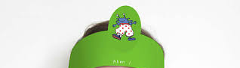 |  | World Book Day  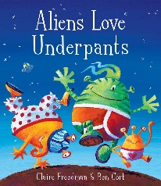  Can you draw your favourite alien from the story on your design an alien activity sheet? Think about the size and colour of the alien. How many eyes, arms and legs does it have? Which pattern do you like best?  See if you can write some sentences to describe it. You could write ‘It has six eyes’. ‘It has 10 legs’.  Design your own pair of underpants using the template in your pack.  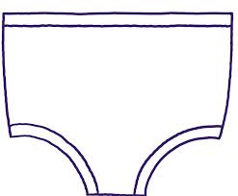  Using a piece of card from your pack, roll it into a cylinder shape. Cut out the circle templates and glue them on to the cylinder. Now cut the template for the top of the rocket, make it and glue it on. Finally, add crepe paper to the bottom.  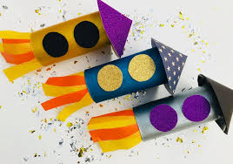
Day 10  Lesson 20 – review the week  https://www.youtube.com/watch?v=bTGhuqCepYQ&feature=youtu.be  Read your reading book. | https://classroom.thenational.academy/lessons/to-tell-the-story-of-the-three-frilly-goats-independently-cct32r  Lesson 10  Use the mini-book in your pack to create your new version of the story. Draw a picture on each page with some words or a sentence to describe what is happening on each page.  Watch the letter formation for the digraphs you have learnt this week. Practise writing them in your book.  https://teachhandwriting.co.uk/continuous-cursive-joins-choice-3.html | Watch the video  Session 4 – Making 10.  https://whiterosemaths.com/homelearning/early-years/building-9-10-week-2/  Cut up they cards and play the game. Can you find the pairs that make 10 together?  Play this adding game.  https://www.topmarks.co.uk/addition/addition-to-10  Can you record any of the number sentences into your book? |  | Make a troll mask  - Cut out the troll pieces on the sheet in your pack.  - Carefully glue them to the piece of card in your pack using your PVA glue.  - Cut around the shape of the troll face and ask a grown up to cut out some eyes.  - Attach a lollipop stick from your pack to the bottom of it and you have your own troll mask.  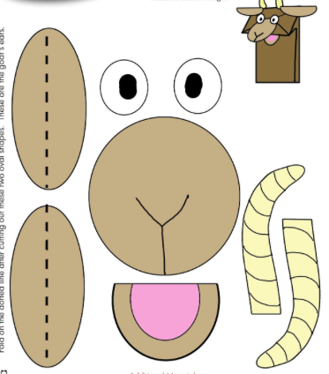  Why don’t you wear it while you have a go at playing this board game in your pack with someone in your home.  