Week 1 – Year 2 All about Tigers
Phonics | English | Maths |  | Other Subjects
DAY 1  Revise some of the phase 5 sounds you know by watching this lesson.  https://www.youtube.com/watch?v=4gUXlOEO-tU&feature=youtu.be | https://classroom.thenational.academy/units/information-all-about-tigers-1d38  Lesson 1  Read your reading book. | Super Mover Warm Up  https://www.bbc.co.uk/teach/supermovers/ks1-maths-counting-with-john-farnworth/zbct8xs  In this unit of work we are going to be doing lots of fun activities related to shape. Here is your first mission. Go on a hunt around your house or maybe even outside with an adult to search for as many triangle shapes as you can. How many can you find? Remember that a triangle has 3 straight sides. Draw each of the triangles you found into your book. How many did you find? Did you find any on the floor? On your clothes? On the wall?  Extra challenge – Can you make a picture that is made up of only triangles and draw it in your book? |  | 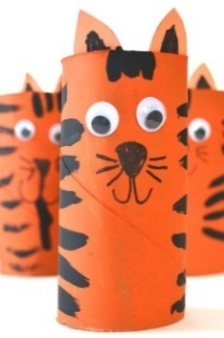  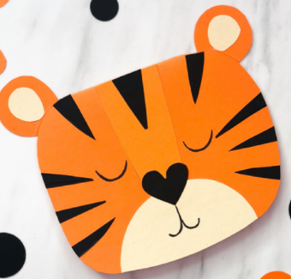  Use some of the materials in your pack to create your own tiger or tigers. You could use a toilet roll cardboard tube to make a 3D tiger like the one in the picture or you could cut out a tiger face shape and add features using pens, paints or paper.
DAY 2  Revise some of the phase 5 sounds you know by watching this lesson.  https://www.youtube.com/watch?v=4Y8jRWf-ry4&feature=youtu.be | https://classroom.thenational.academy/units/information-all-about-tigers-1d38  Lesson 2  Read your reading book. | Super Mover Warm Up  https://www.bbc.co.uk/teach/supermovers/ks1-maths-counting-with-john-farnworth/zbct8xs  Lets Investigate Triangles (https://nrich.maths.org/93)  Cut out your coloured strips and have fun investigating how many different triangles you can make. Stick some of the ones you make into your book. |  | Tiger Inspired Cooking  Watch the story of the Tiger Who Came to Tea  https://www.youtube.com/watch?v=BXgW9UCgpc8  Could you use tigers as an inspiration for making some tasty snacks? You could use orange segments and black grapes to create some tiger stripe fruit kebabs, you could make some biscuits and decorate them with orange and black icing. If you can’t do any cooking then maybe you could design a feast for the Tiger who came to Tea.
DAY 3  Revise some of the phase 5 sounds you know by watching this lesson.  https://www.youtube.com/watch?v=Av38i-MGaus&feature=youtu.be | https://classroom.thenational.academy/units/information-all-about-tigers-1d38  Lesson 3  Read your reading book. | Super Mover Warm Up  https://www.bbc.co.uk/teach/supermovers/ks1-maths-number-bonds-with-martin-dougan/zf6cpg8  Matching Triangles (https://nrich.maths.org/5638)  Cut out all of the triangles. Look at them really carefully. Can you sort them in to groups by the type of triangle they are?  Stick them in to your book.  Extra challenge – Can you draw or cut out another triangle to go in each family? |  | 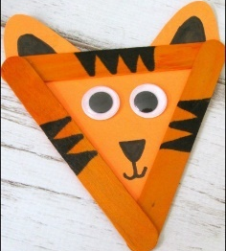  Watch Tom Hardy read the story There’s a Tiger in the Garden  https://www.youtube.com/watch?v=C6XxVmIlUNA  Use 3 lollipop sticks to create a triangle and cut out a triangle of orange card the same size and turn it into a tiger like the picture here.  When you are done create your own imaginary garden. It could have whatever you like in it…including some wild animals if you like. Colour it in and tell someone in your family about it.  Extra challenge – If you wanted to you could make up your own story that takes place in your imaginary garden. You could act it out or write it down.
DAY 4  Revise some of the phase 5 sounds you know by watching this lesson.  https://www.youtube.com/watch?v=PbgFagB_HV0&feature=youtu.be | https://classroom.thenational.academy/units/information-all-about-tigers-1d38  Lesson 4  Read your reading book. | Super Mover Warm Up  https://www.bbc.co.uk/teach/supermovers/ks1-maths-number-bonds-with-martin-dougan/zf6cpg8  Inside Triangles  (https://nrich.maths.org/5648)  Use your dotty paper. How many different triangles can you draw that have one dot inside them? You can use the interactive screen to investigate some different ways first if you would like to. |  | Science  Watch the video about camouflage in the jungle.  https://www.bbc.co.uk/bitesize/clips/z7x76sg  Have a go at using paint or pencils to camouflage the photograph of the tiger skin pattern on the page. Can you carry on the stripes of black and orange so that no one can tell where the picture finishes and your drawing begins? When you are finished stick it in your book.
DAY 5  Revise some of the phase 5 sounds you know by watching this lesson.  https://www.youtube.com/watch?v=mTRNnVP-fRg&feature=youtu.be | https://classroom.thenational.academy/units/information-all-about-tigers-1d38  Lesson 5  Read your reading book. | Super Mover Warm Up  https://www.bbc.co.uk/teach/supermovers/ks1-maths-counting-with-john-farnworth/zbct8xs  Colouring Triangles  (https://nrich.maths.org/171)  How many different ways can you find of colouring the triangles in?  Have fun investigating. You could set yourself some different challenges here. |  | Animal Mix Up  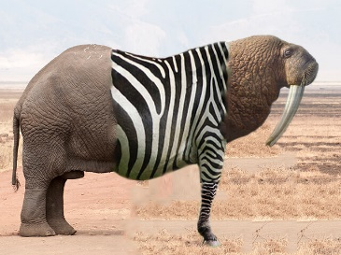  Can you create your own wild animal that is part tiger and part another animal or maybe two more? Draw it into your book.  Think about where it might live, what it might eat and think of a name for it. You could draw and label these things into your book too.
Week 2 – Year 2 - All About Tigers
Phonics | English | Maths |  | Other Subjects
DAY 6  Revise some of the phase 5 sounds you know by watching this lesson.  https://www.youtube.com/watch?v=ys6T0eT-S0Y&feature=youtu.be | https://classroom.thenational.academy/units/information-all-about-tigers-1d38  Lesson 6  Read your reading book. | Super Mover Warm Up https://www.bbc.co.uk/teach/supermovers/ks1-maths-counting-with-john-farnworth/zbct8xs  Repeating Patterns  (https://nrich.maths.org/5944/note)  Cut out your sheets of triangles and use them to create your own repeating patterns. Stick some of your favourite patterns into your book. |  | Watch  https://www.bbc.co.uk/iplayer/episode/b01klvrc/andys-wild-adventures-series-2-4-tigers  Find the photograph of the tiger face in your pack. Look closely at it and then use a pencil to have a go at sketching in the other side of the picture. Use pencils or paint to colour your picture.
DAY 7  Revise some of the phase 5 sounds you know by watching this lesson.  https://www.youtube.com/watch?v=GHjzY-VVNa8&feature=youtu.be | https://classroom.thenational.academy/units/information-all-about-tigers-1d38  Lesson 7  Read your reading book. | Super Mover Warm Up  https://www.bbc.co.uk/teach/supermovers/ks1-maths-counting-with-john-farnworth/zbct8xs  Patterns  Use the shapes in your pack to cut out and make your own shape patterns. Think about what your patterns will be. Can you describe your patterns using the correct shape words?  Extra challenge – What would be the 12th shape in your pattern? |  | Science  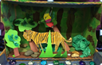  Tigers live in forests, grasslands and swamps.  Think about the things that a tiger would need in its habitat. Draw and cut out your own tiger. Find an empty cereal box and use paper, card board, reclaimed materials, paint, real leaves, stones etc. to create a mini-habitat. Draw and cut out a tiger to live in your wonderful habitat.
DAY 8  Revise some of the phase 5 sounds you know by watching this lesson.  https://www.youtube.com/watch?v=R1jFyRAdH_8&feature=youtu.be | https://classroom.thenational.academy/units/information-all-about-tigers-1d38  Lesson 8  Read your reading book. | Super Mover Warm Up  https://www.bbc.co.uk/teach/supermovers/ks1-maths-number-bonds-with-martin-dougan/zf6cpg8  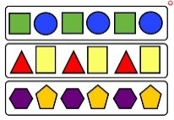  Patterns  Today your challenge is to create your own patterns using shapes of your choice. You could find some small objects to draw around or draw the shapes yourself. Think about what you could change like the size, colour, number of shapes in the pattern etc. Draw and colour your patterns in your book. Ask someone in your family if they can guess which shape will come next in your sequence. |  | Copy out the poem in your best handwriting on a page in your book. Then look closely at the famous ‘Tiger In A Tropical Storm’ painting by Henri Rousseau . Use it to help you create your own illustration for the poem. Have a look at https://www.nationalgallery.org.uk/paintings/henri-rousseau-surprised . Click on the ‘make and create’ button and see if you can create your own. You can work on this over a few days.  Extra Challenge – Write your own tiger poem.
DAY 9  Revise some of the phase 5 sounds you know by watching this lesson.  https://www.youtube.com/watch?v=W-sehqghdT0&feature=youtu.be | https://classroom.thenational.academy/units/information-all-about-tigers-1d38  Lesson 9  Read your reading book. | Super Mover Warm Up  https://www.bbc.co.uk/teach/supermovers/ks1-maths-number-bonds-with-martin-dougan/zf6cpg8  Shape Colouring  Pick some of the shape pictures to colour in. Look closely at what shapes you can spot. Colour them in and think about how you could describe each shape. How many sides and corners do they have? Are they straight or curved? Stick them in your book.  Challenge – Count how many of each shape there are and record. |  | Look at the page of tiger illustrations in your pack. Imagine that you were going to write and illustrate your own tiger book. Try out some different ideas for what you would want your tiger to look like. Create a tiger character and give it a name. If you wanted to you could make your own story book about it. Or create a design for the front cover of the book.
DAY 10  Revise some of the phase 5 sounds you know by watching this lesson.  https://www.youtube.com/watch?v=x7ZP-_oaRo4&feature=youtu.be | https://classroom.thenational.academy/units/information-all-about-tigers-1d38  Lesson 10  Read your reading book. | Super Mover Warm Up  https://www.bbc.co.uk/teach/supermovers/ks1-maths-counting-with-john-farnworth/zbct8xs  Shape Picture  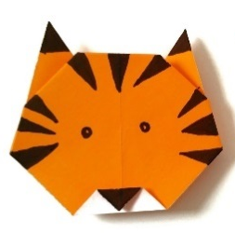  Cut out some of the shapes in your pack to create your own tiger using 2d shapes. If you don’t have some of the shapes you need you can draw them and cut them out yourself. Stick your tiger into your book.  Challenge – Can you make a list of what shapes you used and how many of each you used? |  | Well done you have worked really hard on your tiger work.  Today go on a virtual trip to Chester Zoo.  Watch some of the Virtual Zoo films on this link.  https://www.chesterzoo.org/virtual-zoo-2/  Then pick some of your favourite animals to draw and write about in your book.
Extra Ideas
https://www.bbc.co.uk/teach/live-lessons/numeracy-ks1-lesson-1/zwhkg7h

Reading and Phonics
Please read or listen to three stories throughout the day. You can choose from the book list attached or you may have a book at home that you can read together.
Play some phonics pames on Phonics Play.

Enjoy listening to the books on the BookTrust website and then have a go at some of the games.

https://www.booktrust.org.uk/books-and-reading/have-some-fun/storybooks-and-games

Jez Alborough reads Where's My Teddy
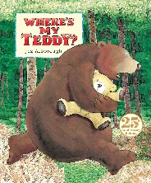
https://www.youtube.com/watch?v=e9w2We3_RM0&list=PLAThMpgCu5chovzKWyxPTIUJ5otyhGz0d&index=3

Michael Rosen performs We're Going on a Bear Hunt

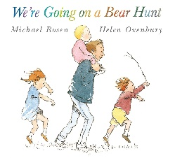
https://www.youtube.com/watch?v=0gyI6ykDwds

The Selfish Crocodile By Faustin Charles Illustrated By Michael Terry

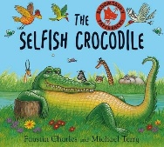
https://www.youtube.com/watch?v=0-NhjfJ_RZI

Michelle and Barack Obama reading Giraffe Problems and The Bear Ate Your Sandwich
https://www.youtube.com/watch?v=vXaYnnnl_34
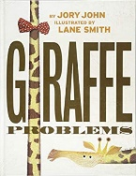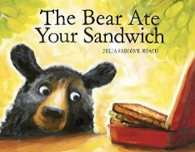

Bill Martin reads Brown Bear, Brown Bear, What Do You See?

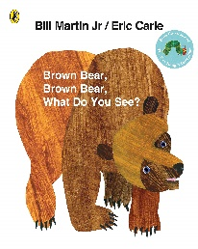

https://www.youtube.com/watch?v=pdHCYgO9zh8&list=PLOGUBkNAfEDUkoBeNOyMCxkTakEc5wugX

Read Aloud - Eat Your Peas - Children's Book - by Kes Gray

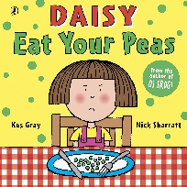

https://www.youtube.com/watch?v=Rab3Iw0qT1U

The Very Hungry Caterpillar by Eric Carle
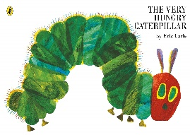
https://www.youtube.com/watch?v=75NQK-Sm1YY

The Day the Crayons Quit' by Drew Daywalt - READ ALOUD FOR KIDS!

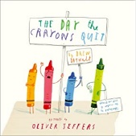

https://www.youtube.com/watch?v=ZttMDho5HMw

Authors Read: The Chameleon Who Couldn't Change Colour

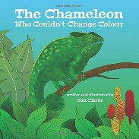

https://www.youtube.com/watch?v=Og9DB06TE8U

Tabby McTat - Read by Alan Mandel

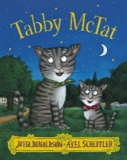

https://www.youtube.com/watch?v=qnYUIz_et-E

A Squash and a Squeeze By Julia Donaldson & Illustrated by Axel Scheffler

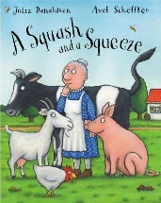

https://www.youtube.com/watch?v=PkdX73Onf04

Jez Alborough reads Albert and Little Henry

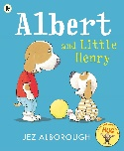

https://www.youtube.com/watch?v=zsybiiiiR00&list=PLAThMpgCu5chovzKWyxPTIUJ5otyhGz0d&index=4

Arnie the Doughnut read by Chris O'Dowd

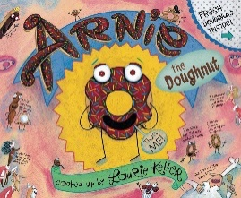

https://www.youtube.com/watch?v=6E67n1vZZjQ

Nick Sharrett reads Shark in the Park
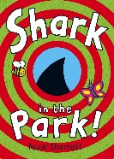
https://www.youtube.com/watch?v=R2RwvAHUAdc

Oi, Get off our Train by John Burningham
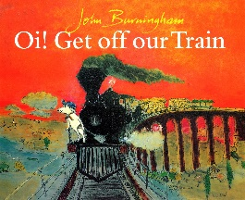
https://www.youtube.com/watch?v=siy2DbR4dZ8&t=241s
How to Catch a Star by Oliver Jeffers
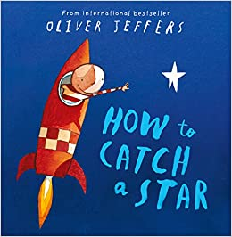
https://www.youtube.com/watch?v=rDMnOx7w6OA

Handa’s Surprise Animation – Eileen Browne
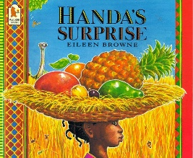
https://www.youtube.com/watch?v=ocnRQi89nK8
Elmer read by David McKee
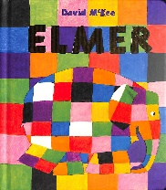
https://www.youtube.com/watch?v=ZFrD18XLmlM
Supertato by Sue Hendra
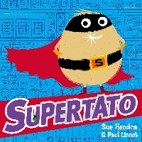
https://www.youtube.com/watch?v=QlaMeNmTG6c
Aliens Love Underpants by Claire Freedman
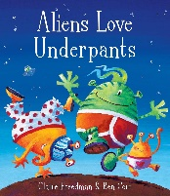
https://www.youtube.com/watch?v=ADnAGBWlzqE
Peace at Last by Jill Murphy
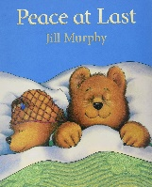
https://www.youtube.com/watch?v=O_pA7tK90_U
Where the Wild Things Are by Maurice Sendak
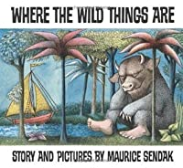
https://www.youtube.com/watch?v=2bptuYPvfgk
The Gruffalo by Julia Donaldson
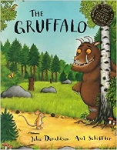
https://www.youtube.com/watch?v=s8sUPpPc8Ws&t=318s
Owl babies by Martin Waddell
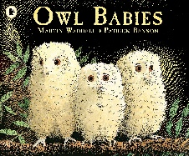
https://www.youtube.com/watch?v=SOEbU2IBnP4
Stick Man by Julia Donaldson
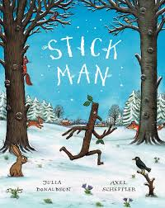
https://www.youtube.com/watch?v=DaHOtYhaJtU
You Choose by Pippa Goodhart
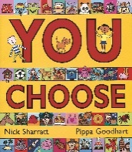
https://www.youtube.com/watch?v=DKf_zyJGkzo
Room on the Broom by Julia Donaldson
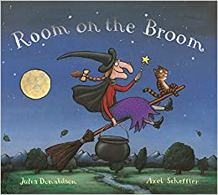
https://www.youtube.com/watch?v=_uQulEnxsRo&t=386s
Not Now Bernard by David McKee
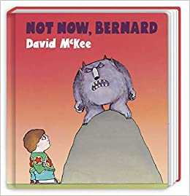
https://www.youtube.com/watch?v=D8JNnf-WouU

The Tiger who Came To Tea by Judith Kerr
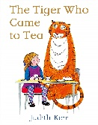
https://www.youtube.com/watch?v=p1_lnmdyR1s

Dogger by Shirley Hughes
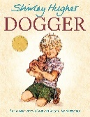
https://www.youtube.com/watch?v=hPJzHwsdjlQ

How to Wash a Woolley Mammoth by Michelle Robinson
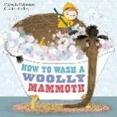
https://www.youtube.com/watch?v=tgQjvEFTHEc
Gorilla by Anthony Browne
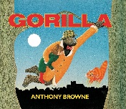
https://www.youtube.com/watch?v=drz8PYwzRnE
Mr Wolf’s Pancakes
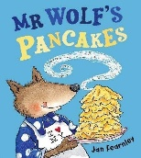
https://www.youtube.com/watch?v=jS43aoN4jnc

