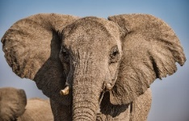
Year 1 – Week 1 – Elephants
Phonics | English | Maths |  | Other Subject Areas
Day 1  https://www.youtube.com/watch?v=66VrNnJSDPw&feature=youtu.be  Read your reading book. Look out for | Watch Mrs Bannister reading the story of The Elephant and the Bad Baby on our blog page.  In your pack you have a picture of a real elephant. Look at it closely and talk about what you notice. Then have a go at labelling different parts of the elephant’s body.  Practise your cursive handwriting. Use the sound that you have focussed on for phonics to apply to words. | Super Movers Warm Up  https://www.bbc.co.uk/teach/supermovers/ks1-maths-counting-with-john-farnworth/zbct8xs  In this unit of work we are going to be doing lots of fun activities related to shape. Here is your first mission. Go on a hunt around your house or maybe even outside with an adult to search for as many triangle shapes as you can. How many can you find? Remember that a triangle has 3 straight sides. Draw each of the triangles you found into your book. How many did you find? Did you find any on the floor? On your clothes? On the wall?  Extra challenge – Can you make a picture that is made up of only triangles and draw it in your book? |  | Watch this short film showing a herd of elephants looking for water.  https://www.bbc.co.uk/teach/class-clips-video/science-ks1-ks2-wonders-of-nature-elephants-looking-for-water/zdnhf4j  Geography  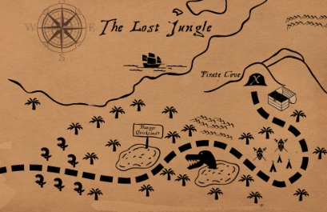  Can you create your own map of a journey that an elephant might have to go on to find a watering hole to drink from? Maybe you will include a dessert, some mud, a forest…it is totally up to you. Draw and cut out your own elephant and have fun moving it across your map and describing the different places as it moves.
Day 2  https://www.youtube.com/watch?v=qDBRiSU6zSg&feature=youtu.be  Read your reading book. | Warm Up Activity  https://www.bbc.co.uk/teach/supermovers/ks1-english-rhyme-with-radzi/zvbm47h  Watch the story of The Elephant and the Bad Baby again. Can you join in with any of  the repeated words this time?  Think about what the baby and the elephant might be saying in the picture and write their words into the speech bubbles. Try to remember a capital letter, finger spaces and a full stop.  Practise your cursive handwriting. Use the sound that you have focussed on for phonics to apply to words. | Super Movers Warm Up  https://www.bbc.co.uk/teach/supermovers/ks1-maths-digits-&-numbers-with-marlon-wallen/zfyjbdm  Lets Investigate Triangles (https://nrich.maths.org/93)  Cut out your coloured strips and have fun investigating how many different triangles you can make. Stick some of the ones you make into your book. |  | Watch Tinga, Tinga Tales – How the elephant got his trunk  https://www.bbc.co.uk/iplayer/episode/b00qn7dv/tinga-tinga-tales-series-1-1-why-elephant-has-a-trunk  Use the pictures from the story as an inspiration for your own drawings of elephants or other African animals. Look at the lovely patterns that the illustrator has drawn on some of the animals., Can you add some interesting patterns into your own pictures and colour them brightly like in the book.
Day 3  https://www.youtube.com/watch?v=NjJzf171tZw&feature=youtu.be  Read your reading book. | Watch or read the story with an adult again. Can you pretend to be some of the different characters in the book? How might they behave? What might they say?  Can you create a story map to show the adventure that the Elephant and the Bad Baby go on?  Use the book to help you get things in the right order on your map. Add some labels to the map to help you remember what each place is.  Practise your cursive handwriting. Use the sound that you have focussed on for phonics to apply to words. | Super Movers Warm Up  https://www.bbc.co.uk/teach/supermovers/ks1-maths-number-bonds-with-martin-dougan/zf6cpg8  Matching Triangles (https://nrich.maths.org/5638)  Cut out all of the triangles. Look at them really carefully. Can you sort them in to groups by the type of triangle they are?  Stick them in to your book.  Extra challenge – Can you draw or cut out another triangle to go in each family? |  | https://www.bbc.co.uk/cbeebies/radio/ten-pieces-optimistic-elephant?collection=radio-ten-pieces-story-time  Listen to the ten pieces radio podcast and join in.  DT  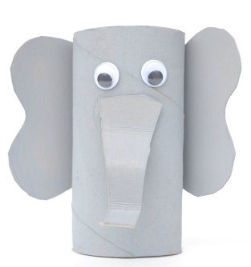  Make your own elephant model. Use the card strips and masking tape to make a tube. Cut out ears, eyes and a trunk and attach them to the tube. Paint it grey or colour it in however you like. Maybe you could create a rainbow elephant?  You could even make a whole family of elephants by cutting your tubes to different sizes before you decorate them.
Day 4  https://www.youtube.com/watch?v=ckqNWTB5c4M&feature=youtu.be  Read your reading book. | Warm up activity  https://www.bbc.co.uk/teach/supermovers/ks1-english-capital-letters-full-stops/zjmrhbk  Find the sheet with the four pictures from the story. Write a simple sentence to go with each picture to explain what is happening. Remember to say your sentence out loud first, then write it down using finger spaces and a full stop at the end. Read your sentence back to make sure it makes sense.  Practise your cursive handwriting. Use the sound that you have focussed on for phonics to apply to words. | Super Movers Warm Up  https://www.bbc.co.uk/teach/supermovers/ks1-maths-length-height/zdrx92p  Inside Triangles  (https://nrich.maths.org/5648)  Use your dotty paper. How many different triangles can you draw that have one dot inside them? You can use the interactive screen to investigate some different ways first if you would like to. |  | Watch this programme.  https://www.bbc.co.uk/cbeebies/stories/melody-noisy-elephant  Elephants can blow through their trunks to make a loud sound. It is a bit like a trumpet. Can you create your own elephant music?  You could create your own trumpet to play by following the instructions in your pack or you could create your own drum by using a saucepan or a box with a wooden spoon and march to the beat like an elephant herd marching across the plains.
Day 5  https://www.youtube.com/watch?v=W9pMGELqNEc&feature=youtu.be  Read your reading book. | Warm Up Activity  https://www.bbc.co.uk/teach/supermovers/ks1-english-punctuation-with-karim-hacker/zrksqp3  Pick one of the shops from the story. Can you write a shopping list of things that you might be able to buy from that shop?  Write your list into your book. Add a picture to each item to make it easier for a baby to understand. Can you think of 10 things to go on your list?  Play the Shopping Game with someone in your family. You could colour the game board in to make it more colourful too.  Practise your cursive handwriting. Use the sound that you have focussed on for phonics to apply to words. | Super Movers Warm Up  https://www.bbc.co.uk/teach/supermovers/ks1-maths-money/zht4nrd  Colouring Triangles  (https://nrich.maths.org/171)  How many different ways can you find of colouring the triangles in?  Have fun investigating. You could set yourself some different challenges here. |  | https://www.bbc.co.uk/iplayer/episode/p064l4xr/happy-tent-tales-5mice-and-elephants  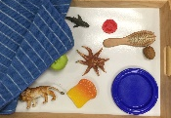  There is a traditional saying that says ‘an elephant never forgets’. Today have fun playing some memory games. You could play Kim’s Game. Pick 10 objects from around your house and look at them carefully. Get someone in your family to cover them over with a blanket and then take one away without you seeing. Can you remember which one has gone? You could also make or play a pairs game. Lay some cards face down and take it in turns to turn two over. If they match you can keep them. You could play this with the high frequency word cards in your pack or you could make your own with letter sounds, shapes, colours, animals or anything else that interests you.

Year 1 - Week 2
Phonics | English | Maths |  | Other Subjects
Day 6  https://www.youtube.com/watch?v=W9pMGELqNEc&feature=youtu.be  Read your reading book. | Read or watch the story again.  Use some white card from your pack and the lollipop sticks to create some of the different characters from the story. Can you use your little puppets to retell the story in your own way?  Find an audience to tell the story to. It could be someone in your family, a pet or even some of your toys.  Practise your cursive handwriting. Use the sound that you have focussed on for phonics to apply to words. | Super Mover Warm Up https://www.bbc.co.uk/teach/supermovers/ks1-maths-counting-with-john-farnworth/zbct8xs  Repeating Patterns  (https://nrich.maths.org/5944/note)  Cut out your sheets of triangles and use them to create your own repeating patterns. Stick some of your favourite patterns into your book. |  | Watch this programme to find out some information about elephants.  https://www.bbc.co.uk/iplayer/episode/b01cbn46/andys-wild-adventures-series-1-2-elephants  Get Creative  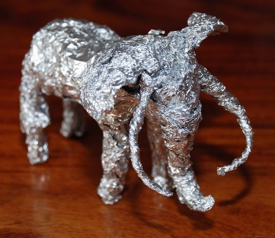  Use some tin foil to create your own 3D elephant sculpture. You can twist the foil to make legs and a trunk and use a ball of foil for the body. Think about how you will make the ears. If you encounter a problem try to think of a way around it.
Day 7  https://www.youtube.com/watch?v=gJhNxURKtIo&feature=youtu.be  Read your reading book. | Warm Up  https://www.bbc.co.uk/teach/supermovers/ks1-english-alphabet-with-naomi-wilkinson/zjjy2sg  Think of some other shops or places where the Elephant and the Bad Baby could have visited.  Can you draw one or two of these into your book and write sentences to explain what they might have got from each place?  Practise your cursive handwriting. Use the sound that you have focussed on for phonics to apply to words. | Super Mover Warm Up  https://www.bbc.co.uk/teach/supermovers/ks1-maths-counting-with-john-farnworth/zbct8xs  Patterns  Use the shapes in your pack to cut out and make your own shape patterns. Think about what your patterns will be. Can you describe your patterns using the correct shape words?  Extra challenge – What would be the 12th shape in your pattern? |  | Make you own family of elephants. Use your paints to paint a background or draw one with some pens and pencils. Draw around your own hand on grey paper and cut it out. Ask other people in your house if you can draw around their hands too. Cut them out and turn them into elephants to stick onto your picture. You could colour them and decorate them however you like.
Day 8  https://www.youtube.com/watch?v=AAIs6YzFTYM&feature=youtu.be  Read your reading book. | In the story the Baby did not have very good manners. Can you create your own list of rules that you think would help the baby? Write them in your book and add pictures to each one.  Practise your cursive handwriting. Use the sound that you have focussed on for phonics to apply to words. | Super Mover Warm Up  https://www.bbc.co.uk/teach/supermovers/ks1-maths-number-bonds-with-martin-dougan/zf6cpg8  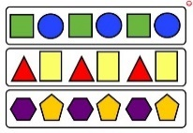  Patterns  Today your challenge is to create your own patterns using shapes of your choice. You could find some small objects to draw around or draw the shapes yourself. Think about what you could change like the size, colour, number of shapes in the pattern etc. Draw and colour your patterns in your book. Ask someone in your family if they can guess which shape will come next in your sequence. |  | Work with an adult to see if you can find out some more facts about elephants on this website.  https://kids.nationalgeographic.com/animals/mammals/african-elephant/  Use what you have learned this week to help you create a poster all about elephants. You can cut out and stick the photographs in your pack, onto the A3 folded paper, if you want to or draw your own.
Day 9  https://www.youtube.com/watch?v=OO49S-qXQxE&feature=youtu.be  Read your reading book. | Warm Up  https://www.bbc.co.uk/teach/supermovers/ks1-english-syllables-with-joe-tracini/znt4nrd  Can you create a story map in your book to show a new adventure that the Elephant might go on, and whom he might meet along the way? Add some labels to the map to help you remember what each place is.  Practise your cursive handwriting. Use the sound that you have focussed on for phonics to apply to words. | Super Mover Warm Up  https://www.bbc.co.uk/teach/supermovers/ks1-maths-number-bonds-with-martin-dougan/zf6cpg8  Shape Colouring  Pick some of the shape pictures to colour in. Look closely at what shapes you can spot. Colour them in and think about how you could describe each shape. How many sides and corners do they have? Are they straight or curved? Stick them in your book.  Challenge – Count how many of each shape there are and record. |  | Use your model Magic clay to create a 3D model of an elephant. Remember to add details like a trunk and maybe some tusks. Leave your model magic to dry. When it has dried you can paint it with your watercolours or colour it in with felt tip pens.
Day 10  https://www.youtube.com/watch?v=KtORLbwPB8U&feature=youtu.be  Read your reading book. | Can you use your little book to create your very own story about an elephant? Where might it go? Who might it meet? What will happen in the end? Have fun drawing the picture to tell the story and then add a sentence to each page. Share your book with someone in your house.  Practise your cursive handwriting. Use the sound that you have focussed on for phonics to apply to words. | Super Mover Warm Up  https://www.bbc.co.uk/teach/supermovers/ks1-maths-counting-with-john-farnworth/zbct8xs  Shape Picture  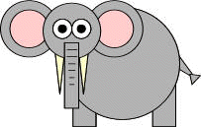  Cut out some of the shapes in your pack to create your own elephant using 2d shapes. If you don’t have some of the shapes you need you can draw them and cut them out yourself. Stick your elephant into your book.  Challenge – Can you make a list of what shapes you used and how many of each you used? |  | Use your watercolour paints to paint a beautiful African sunset background. Then leave it to dry. When it is nice and dry use you blank watercolour paint to create the silouette of a tree and an elephant like the giraffe one below.
Extra Ideas
Can you come up with your own elephant themed cooking idea?  Here are a few suggestions…  Could you make some elephant head shapes bread rolls?  Could you make some biscuits or decorate some to look like elephant faces?  Could you make a healthy elephant snack using different fruits?  Draw your finished creation into your book. How many stars out of 5 would you give it for how it tasted? | 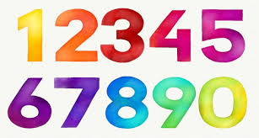Number formation practise sheets.  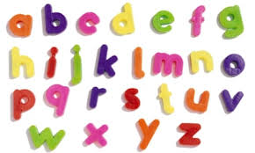Letter formation practise sheets.  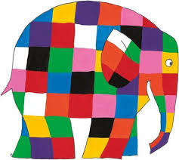Create your own Elmer elephant using coloured crayons or pens.

Enjoy listening to the books on the BookTrust website and then have a go at some of the games.

https://www.booktrust.org.uk/books-and-reading/have-some-fun/storybooks-and-games

Jez Alborough reads Where's My Teddy
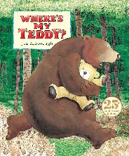
https://www.youtube.com/watch?v=e9w2We3_RM0&list=PLAThMpgCu5chovzKWyxPTIUJ5otyhGz0d&index=3

Michael Rosen performs We're Going on a Bear Hunt

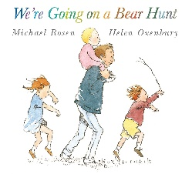
https://www.youtube.com/watch?v=0gyI6ykDwds

The Selfish Crocodile By Faustin Charles Illustrated By Michael Terry

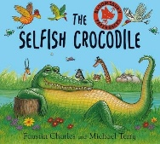
https://www.youtube.com/watch?v=0-NhjfJ_RZI

Michelle and Barack Obama reading Giraffe Problems and The Bear Ate Your Sandwich
https://www.youtube.com/watch?v=vXaYnnnl_34
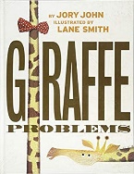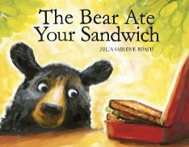

Bill Martin reads Brown Bear, Brown Bear, What Do You See?

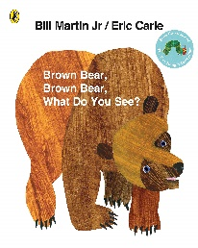

https://www.youtube.com/watch?v=pdHCYgO9zh8&list=PLOGUBkNAfEDUkoBeNOyMCxkTakEc5wugX

Read Aloud - Eat Your Peas - Children's Book - by Kes Gray

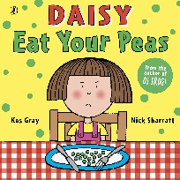

https://www.youtube.com/watch?v=Rab3Iw0qT1U

The Very Hungry Caterpillar by Eric Carle
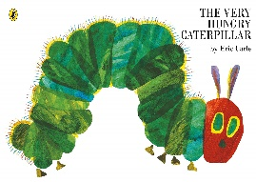
https://www.youtube.com/watch?v=75NQK-Sm1YY
The Day the Crayons Quit' by Drew Daywalt - READ ALOUD FOR KIDS!

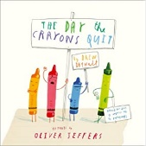

https://www.youtube.com/watch?v=ZttMDho5HMw

Authors Read: The Chameleon Who Couldn't Change Colour

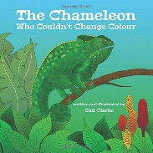

https://www.youtube.com/watch?v=Og9DB06TE8U

Tabby McTat - Read by Alan Mandel

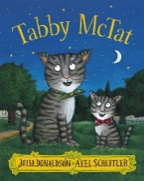

https://www.youtube.com/watch?v=qnYUIz_et-E

A Squash and a Squeeze By Julia Donaldson & Illustrated by Axel Scheffler

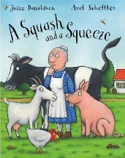

https://www.youtube.com/watch?v=PkdX73Onf04

Jez Alborough reads Albert and Little Henry

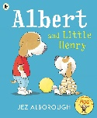

https://www.youtube.com/watch?v=zsybiiiiR00&list=PLAThMpgCu5chovzKWyxPTIUJ5otyhGz0d&index=4

Arnie the Doughnut read by Chris O'Dowd

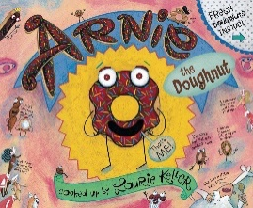

https://www.youtube.com/watch?v=6E67n1vZZjQ

Nick Sharrett reads Shark in the Park
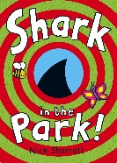
https://www.youtube.com/watch?v=R2RwvAHUAdc

Oi, Get off our Train by John Burningham
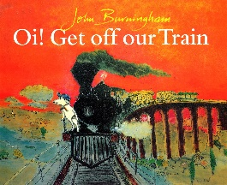
https://www.youtube.com/watch?v=siy2DbR4dZ8&t=241s
How to Catch a Star by Oliver Jeffers
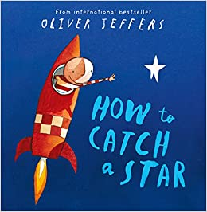
https://www.youtube.com/watch?v=rDMnOx7w6OA
Handa’s Surprise Animation – Eileen Browne
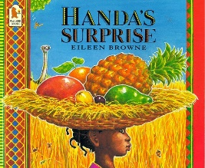
https://www.youtube.com/watch?v=ocnRQi89nK8
Elmer read by David McKee
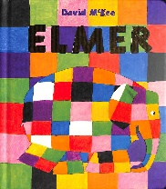
https://www.youtube.com/watch?v=ZFrD18XLmlM
Supertato by Sue Hendra
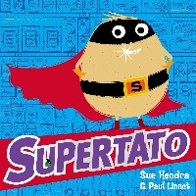
https://www.youtube.com/watch?v=QlaMeNmTG6c
Aliens Love Underpants by Claire Freedman
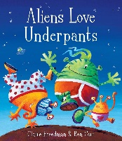
https://www.youtube.com/watch?v=ADnAGBWlzqE
Peace at Last by Jill Murphy
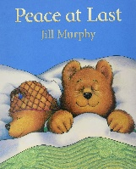
https://www.youtube.com/watch?v=O_pA7tK90_U
Where the Wild Things Are by Maurice Sendak
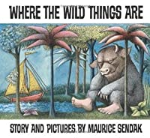
https://www.youtube.com/watch?v=2bptuYPvfgk

The Gruffalo by Julia Donaldson
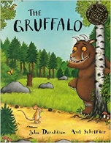
https://www.youtube.com/watch?v=s8sUPpPc8Ws&t=318s

Owl babies by Martin Waddell
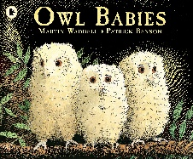
https://www.youtube.com/watch?v=SOEbU2IBnP4

Stick Man by Julia Donaldson
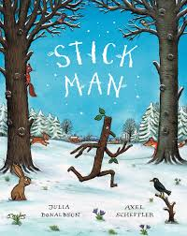
https://www.youtube.com/watch?v=DaHOtYhaJtU

You Choose by Pippa Goodhart
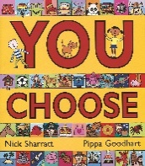
https://www.youtube.com/watch?v=DKf_zyJGkzo
Room on the Broom by Julia Donaldson
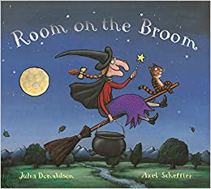
https://www.youtube.com/watch?v=_uQulEnxsRo&t=386s
Not Now Bernard by David McKee
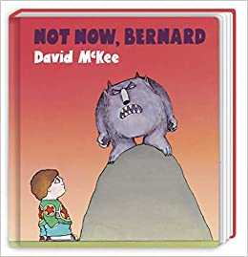
https://www.youtube.com/watch?v=D8JNnf-WouU
The Tiger who Came To Tea by Judith Kerr
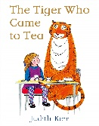
https://www.youtube.com/watch?v=p1_lnmdyR1s

Dogger by Shirley Hughes
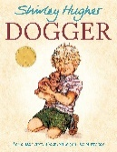
https://www.youtube.com/watch?v=hPJzHwsdjlQ

How to Wash a Woolley Mammoth by Michelle Robinson
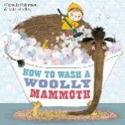
https://www.youtube.com/watch?v=tgQjvEFTHEc
Gorilla by Anthony Browne
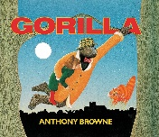
https://www.youtube.com/watch?v=drz8PYwzRnE
Mr Wolf’s Pancakes
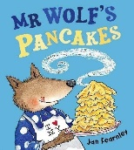
https://www.youtube.com/watch?v=jS43aoN4jnc

