Week 1 – EYFS The Little Red Hen
Daily – Try to read or watch at least 3 stories a day. Do some physical activities. You could do some Cosmic Kids Yoga (https://www.cosmickids.com/category/watch/ ), Go Noodle (https://www.gonoodle.com/ ) or Just Dance on You Tube. You could make up some different exercises to do at home.
Phonics | English | Maths |  | Physical Development, Understanding the World and Expressive Arts and Design
Day 1  Watch lesson 1.  https://www.youtube.com/watch?v=lqOl4AcilIo&feature=youtu.be  Read your reading book. | https://classroom.thenational.academy/units/little-red-hen-2e6d  Lesson 1  Listen to your teacher read The Little Red Hen on the class blog. | Pick a counting song to learn today …  https://www.bbc.co.uk/teach/school-radio/nursery-rhymes-counting-songs/zn67kmn  Watch these 2 short programs.  https://www.bbc.co.uk/iplayer/episode/b08bzzns/numberblocks-series-1-one  https://www.bbc.co.uk/iplayer/episode/b08c001f/numberblocks-series-1-another-one  Watch the episode about number 1 and another 1. Have a go for hunting for things in your house that you can find one of. Try writing the number one in the air, with some paint, make it with your playdough and draw some into your book. |  | Spend time enjoying the story together. Look at the illustrations and talk about what is happening and how the characters might be feeling. You could watch your teacher reading the story on the blog.  Cooking Activity  In the story the Little Red Hen goes looking for someone to help cut the corn. In the end she makes some bread. Can you make your own bread? You could even make your own butter. (See enclosed sheet) If you don’t have the ingredients for bread think about something else you could make using the flour. Have fun and enjoy tasting your creations when you finish.
Day 2  Watch lesson 2.  https://www.youtube.com/watch?v=QCkoHFnQf4c&feature=youtu.be  Read your reading book. | https://classroom.thenational.academy/units/little-red-hen-2e6d  Lesson 2  Make a story map – use the map of the farmyard and make your own underneath. | Pick a counting song to learn today …  https://www.bbc.co.uk/teach/school-radio/nursery-rhymes-counting-songs/zn67kmn  Watch the episode of Numberblocks about number 2.  https://www.bbc.co.uk/iplayer/episode/b08bzgt8/numberblocks-series-1-two  Use your numberline. Can you find the number 2? Which numbers does it sit next to on the numberline? Can you make your own numberline to 10? You could draw it in your book or you could draw it outside in chalk. What can you find in your house that comes in 2s? Draw them in your book. |  | Physical Activity  Create your own Little Red Hen challenge trail. Can you challenge yourself to over, under and through different things that you can find at home? Maybe you could pretend that they are things from the story. A chair could be a fence to wriggle under. Use your imagination to help you go on an adventure.  Find your chicken outline in your pack. Use a pen or a pencil to add feathers to your Little Red Hen. How carefully can you add your feather design? Then you could try colouring it in with pencils, pens or paint. Maybe you would like a multi-coloured hen instead of a red hen!
Day 3  Watch lesson 3.  https://www.youtube.com/watch?v=yhxnA6ZNjvk&feature=youtu.be  Read your reading book. | https://classroom.thenational.academy/units/little-red-hen-2e6d  Lesson 3  Act out the story. Can you make the right faces to show how the Little Red Hen is feeling? | Pick a counting song to learn today …  https://www.bbc.co.uk/teach/school-radio/nursery-rhymes-counting-songs/zn67kmn  Watch the episode of Numberblocks about number 3 and 1,2 and 3.  https://www.bbc.co.uk/iplayer/episode/b08bzgxx/numberblocks-series-1-three  https://www.bbc.co.uk/iplayer/episode/b08bzh11/numberblocks-series-1-one-two-three  Can you draw the Numberblocks 1, 2 and 3 into your book? Can you find other ways of drawing 1,2 and 3. You could draw counters, toys, animals, 1p coins. |  | Puppets  Make some Little Red Hen puppets to go with the story.  Use the card and the lollipop sticks in your pack to create puppets of some of the different animals in the story. You could colour or paint them. You could stick things on to make them look extra special.
Day 4  Watch lesson 4.  https://www.youtube.com/watch?v=Q0NhvOaLbY4&feature=youtu.be  Read your reading book. | https://classroom.thenational.academy/units/little-red-hen-2e6d  Lesson 4  Use the puppets you have made and use different voices for each character to retell the story. | Pick a counting song to learn today …  https://www.bbc.co.uk/teach/school-radio/nursery-rhymes-counting-songs/zn67kmn  Watch the episode of Numberblocks about number 4.  https://www.bbc.co.uk/iplayer/episode/b08d61cv/numberblocks-series-1-four  Play Numberblocks roll and colour.  Roll your dice and count the spots. Then colour in the Numberblock that matches your number. Can you colour all the numbers?  Can you cut and order the different size hens? |  | Little Red Hen Map  Look at the farmyard story map in your pack. What things can you see? Where did The Little Red Hen go? Can you create your own map on this page? You could draw your map and then paint it or colour it in with pens or pencils. You could even make your own 3D map on the floor using toys or boxes to create different parts of the farm or you could use chalks to draw it outside on the ground. You could use your little puppets to tell the story on your map.
Day 5  Watch lesson 5.  https://www.youtube.com/watch?v=OQ1AnMCGTzg&feature=youtu.be  Read your reading book. | https://classroom.thenational.academy/units/little-red-hen-2e6d  Lesson 5  Tell the story to your favourite teddy. | Pick a counting song to learn today …  https://www.bbc.co.uk/teach/school-radio/nursery-rhymes-counting-songs/zn67kmn  Watch the episode of Numberblocks about number 5.  Can you cut out and sort the pictures by counting the numbers one to 5. Stick them in the right place on the chart. |  | Expressive Arts Activity  Create your own musical instruments using things you can find around the house. You could make a shaker by putting rice in an empty packet or bottle, you could use pots and pans to make drums or elastic bands on a tissue box to make a little guitar. You can every make your own body percussion with your hands, feet and voices. Use your instruments to make up your own music and song about the Little Red Hen. You could even try and include some rhyming words like hen ten, men, Ben etc in your song.  Here are some musical instrument ideas if you need some help.  https://www.activityvillage.co.uk/musical-instruments

Week 2 – EYFS The Little Red Hen
Phonics | English | Maths |  | Physical, Knowledge and Understanding of the World and Expressive Arts
Day 6  Watch lesson 6.  https://www.youtube.com/watch?v=jFR1LoM6Giw&feature=youtu.be  Read your reading book. | https://classroom.thenational.academy/units/little-red-hen-2e6d  Lesson 6  With your grown up, think of some different endings for the story. | Pick a counting song to learn today …  https://www.bbc.co.uk/teach/school-radio/nursery-rhymes-counting-songs/zn67kmn  Watch the Numberblocks episode about number 6.  https://www.bbc.co.uk/iplayer/episode/b08pgksd/numberblocks-series-2-six  Play I spy number 6. Circle all of the pictures that show 6. Can you draw 6 things into your book? Maybe you could draw 6 red hens? |  | Make your own little book to tell the story of the Little Red Hen.  You could make your own book using some paper or use the mini-book that is in your pack.  You could draw pictures and add words. You have a word bank in your pack if you want to try writing some words from the story.
Day 7  Watch lesson 7.  https://www.youtube.com/watch?v=mTpbxjasiQI&feature=youtu.be  Read your reading book. | https://classroom.thenational.academy/units/little-red-hen-2e6d  Lesson 7  Can you sing your new version of the story? | Pick a counting song to learn today …  https://www.bbc.co.uk/teach/school-radio/nursery-rhymes-counting-songs/zn67kmn  Watch the Numberblocks episode about number 7.  https://www.bbc.co.uk/iplayer/episode/b08pgqt4/numberblocks-series-2-seven  Can you put your Numberblock cards in order from 1-10? Practise writing your numbers on the number formation sheet.  Then write your numbers into your book and draw the blocks to match. |  | https://www.youtube.com/watch?v=Z2XV7Xg7gww  What this short clip on how to make your own rocking chicken. Use the circle outlines and some card to help you.  Can you give your chicken a name and have a go at writing it?
Day 8  Watch lesson 8.  https://www.youtube.com/watch?v=TPQhwBfKC-g&feature=youtu.be  Read your reading book. | https://classroom.thenational.academy/units/little-red-hen-2e6d  Lesson 8  Can you tell your new version of the story using actions? | Pick a counting song to learn today …  https://www.bbc.co.uk/teach/school-radio/nursery-rhymes-counting-songs/zn67kmn  Watch the Numberblocks episode about number 8.  https://www.bbc.co.uk/iplayer/episode/b08pgvmb/numberblocks-series-2-eight  Have a go at drawing some 8s into your book. Can you draw an octopus with 8 legs? Can you draw a spider and give it 8 legs? |  | Have a go at finding out some information about chickens.  Listen to this podcast about chickens  https://www.bbc.co.uk/cbeebies/radio/my-pet-and-me-chickens  Have a think about how chickens grow from an egg to an adult chicken. Look at the photos in your pack. Could you cut them out and order them? Could you make your own picture or painting or model to show the chicken life cycle? Egg – chick – chicken
Day 9  Watch lesson 9.  https://www.youtube.com/watch?v=WyeO5KFNtZU&feature=youtu.be  Read your reading book. | https://classroom.thenational.academy/units/little-red-hen-2e6d  Lesson 9  Draw the characters from the story in your home learning book. | Pick a counting song to learn today …  https://www.bbc.co.uk/teach/school-radio/nursery-rhymes-counting-songs/zn67kmn  Watch the Numberblocks episode about number 9.  https://www.bbc.co.uk/iplayer/episode/b08phbzc/numberblocks-series-2-nine  Have a go at finding all the representations of 9 on your I spy 9 sheet. Count carefully.  Can you write the numbers up to 10 in your book?  Can you find the number 9 on your number line?  Can you find 9 socks in your drawer? Can you see a number 9 on a door or number plate if you look out of your window?  Can you complete the Little Red Hen counting activity? |  | Find out a little about what sorts of things might happen on a real farm by watching this.  https://www.bbc.co.uk/iplayer/episode/b09bj0j8/down-on-the-farm-series-3-11-sheep-and-bat-walk  In the story of the Little Red Hen she asks the other animals for help but they won’t help her.  Can you think of some jobs that you could do that might help someone else in your family? You could match up pairs of socks that have come out of the washing, you could do some washing up or you could help to look after a pet. Draw some of the helpful things that you have done into your book and label them or get your grown up to label them for you. Well done for being so helpful.  You could watch this story about Little Miss Helpful if you like. She tries to be helpful but it doesn’t always work out so well.  https://www.youtube.com/watch?v=L6f_x4N7PYg
Day 10  Watch lesson 10.  https://www.youtube.com/watch?v=6HvzusTPPuE&feature=youtu.be  Read your reading book. | https://classroom.thenational.academy/units/little-red-hen-2e6d  Lesson 10  Can you draw your favourite character from the original story and one from your new version? | Pick a counting song to learn today …  https://www.bbc.co.uk/teach/school-radio/nursery-rhymes-counting-songs/zn67kmn  Watch the Numberblocks episode about number 10.  https://www.bbc.co.uk/iplayer/episode/b08phr1g/numberblocks-series-2-ten  Can you use your playdough to make the number 10. Can you make the 1 and then the 0? Can you make 10 sausages? How about ten footballs? Ten bugs? Can you find the number 10 in a book or somewhere in your house? |  | Can you name some of the shapes that you have on this sheet in your pack? Can you use them to create your own little red hen? Stick it in your book. Can you write the word  h –e – n to go with it or maybe a sentence?

Enjoy listening to the books on the BookTrust website and then have a go at some of the games.

https://www.booktrust.org.uk/books-and-reading/have-some-fun/storybooks-and-games

Jez Alborough reads Where's My Teddy
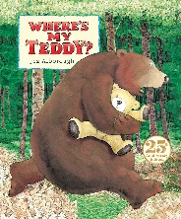
https://www.youtube.com/watch?v=e9w2We3_RM0&list=PLAThMpgCu5chovzKWyxPTIUJ5otyhGz0d&index=3

Michael Rosen performs We're Going on a Bear Hunt

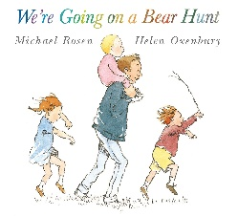
https://www.youtube.com/watch?v=0gyI6ykDwds

The Selfish Crocodile By Faustin Charles Illustrated By Michael Terry

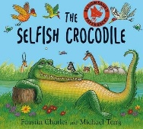
https://www.youtube.com/watch?v=0-NhjfJ_RZI

Michelle and Barack Obama reading Giraffe Problems and The Bear Ate Your Sandwich
https://www.youtube.com/watch?v=vXaYnnnl_34
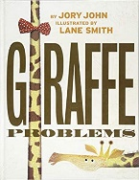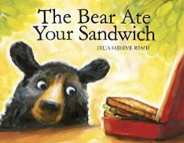

Bill Martin reads Brown Bear, Brown Bear, What Do You See?

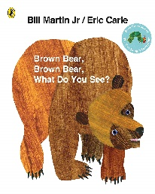

https://www.youtube.com/watch?v=pdHCYgO9zh8&list=PLOGUBkNAfEDUkoBeNOyMCxkTakEc5wugX

Read Aloud - Eat Your Peas - Children's Book - by Kes Gray

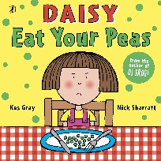

https://www.youtube.com/watch?v=Rab3Iw0qT1U

The Very Hungry Caterpillar by Eric Carle
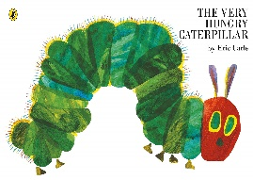
https://www.youtube.com/watch?v=75NQK-Sm1YY

The Day the Crayons Quit' by Drew Daywalt - READ ALOUD FOR KIDS!

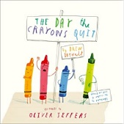

https://www.youtube.com/watch?v=ZttMDho5HMw

Authors Read: The Chameleon Who Couldn't Change Colour

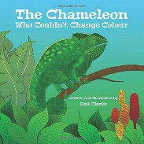

https://www.youtube.com/watch?v=Og9DB06TE8U

Tabby McTat - Read by Alan Mandel

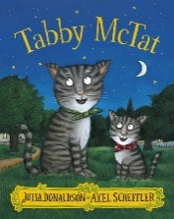

https://www.youtube.com/watch?v=qnYUIz_et-E

A Squash and a Squeeze By Julia Donaldson & Illustrated by Axel Scheffler

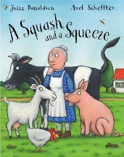

https://www.youtube.com/watch?v=PkdX73Onf04

Jez Alborough reads Albert and Little Henry

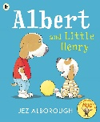

https://www.youtube.com/watch?v=zsybiiiiR00&list=PLAThMpgCu5chovzKWyxPTIUJ5otyhGz0d&index=4

Arnie the Doughnut read by Chris O'Dowd

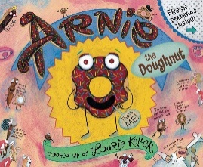

https://www.youtube.com/watch?v=6E67n1vZZjQ

Nick Sharrett reads Shark in the Park
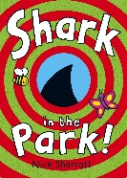
https://www.youtube.com/watch?v=R2RwvAHUAdc

Oi, Get off our Train by John Burningham
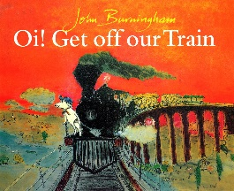
https://www.youtube.com/watch?v=siy2DbR4dZ8&t=241s
How to Catch a Star by Oliver Jeffers
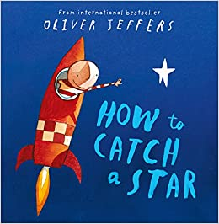
https://www.youtube.com/watch?v=rDMnOx7w6OA

Handa’s Surprise Animation – Eileen Browne
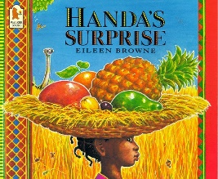
https://www.youtube.com/watch?v=ocnRQi89nK8
Elmer read by David McKee
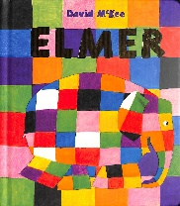
https://www.youtube.com/watch?v=ZFrD18XLmlM
Supertato by Sue Hendra
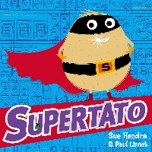
https://www.youtube.com/watch?v=QlaMeNmTG6c
Aliens Love Underpants by Claire Freedman
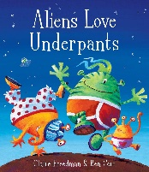
https://www.youtube.com/watch?v=ADnAGBWlzqE
Peace at Last by Jill Murphy
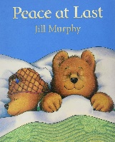
https://www.youtube.com/watch?v=O_pA7tK90_U
Where the Wild Things Are by Maurice Sendak
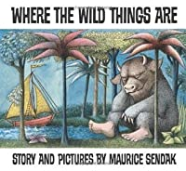
https://www.youtube.com/watch?v=2bptuYPvfgk

The Gruffalo by Julia Donaldson
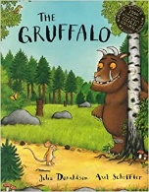
https://www.youtube.com/watch?v=s8sUPpPc8Ws&t=318s

Owl babies by Martin Waddell
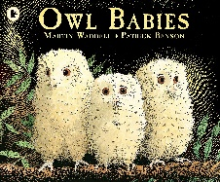
https://www.youtube.com/watch?v=SOEbU2IBnP4

Stick Man by Julia Donaldson
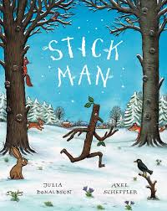
https://www.youtube.com/watch?v=DaHOtYhaJtU
You Choose by Pippa Goodhart
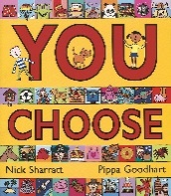
https://www.youtube.com/watch?v=DKf_zyJGkzo
Room on the Broom by Julia Donaldson
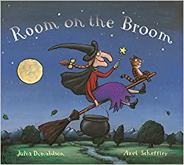
https://www.youtube.com/watch?v=_uQulEnxsRo&t=386s
Not Now Bernard by David McKee
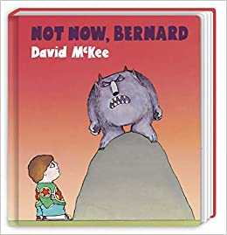
https://www.youtube.com/watch?v=D8JNnf-WouU

The Tiger who Came To Tea by Judith Kerr
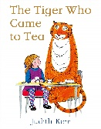
https://www.youtube.com/watch?v=p1_lnmdyR1s

Dogger by Shirley Hughes
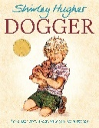
https://www.youtube.com/watch?v=hPJzHwsdjlQ

How to Wash a Woolley Mammoth by Michelle Robinson
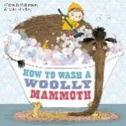
https://www.youtube.com/watch?v=tgQjvEFTHEc

Gorilla by Anthony Browne
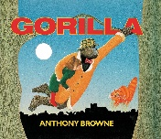
https://www.youtube.com/watch?v=drz8PYwzRnE
Mr Wolf’s Pancakes
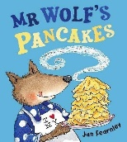
https://www.youtube.com/watch?v=jS43aoN4jnc

